STANDARDIZATION OF OPTIMUM CONDITIONS FOR HYDRLOLYSES OF GOAT MILK WHEY PROTEIN WITH TRYPSIN ENZYME
APOORVA ARGADE AND S.S. AHLAWAT*
Department of Livestock Products Technology
College of Veterinary Science, Lala Lajpat Rai University of Veterinary and Animal Sciences, Hisar-125004, INDIA
*Corresponding author, Email: ahlawatss9@gmail.com

ABSTRACT

Goat milk is as close to perfect food as possible in nature and was known as “the king of milk” in the world, but the development of functional foods from goat milk has been slow compared to cow and buffalo milk. The study was conducted with an objective to develop a goat milk whey protein hydrolysate (GMWPH) with enhanced antioxidant property and better Ca⁺ chelating activity. Goat milk whey protein was digested with commercial food-grade Trypsin enzyme under various conditions of incubation temperature (30 to 70 ⁰C), incubation time (30 to 300 min), enzyme concentration level (0.25 to 2%) and pH (6 to 10) of the enzyme reaction to achieve the best hydrolysis. The hydrolysates were analyzed for degree of hydrolysis (DH), antioxidant activity (DPPH) and calcium chelating capacity. It was found that treatment with trypsin at 40 ⁰C incubation temperature, 180 min incubation time, 1.0% enzyme concentration and 8.0 pH effectively degraded the goat milk whey proteins, as determined by SDS-PAGE and measurement of nonprotein nitrogen content. Hydrolysis with trypsin resulted in a significant increase in antioxidant and Ca⁺ chelation property. Hence, the GMWPH may be useful for development of novel foods for infants, and the elderly osteoporosis patients to replace cow milk.
Keywords: Goat whey protein, Enzymatic hydrolysis, degree of hydrolysis, antioxidant, calcium chelating activity.
INTRODUCTION

Goat milk is as close to perfect food as possible in nature and was known as “the king of milk” in the world (Agnihotri and Prasad, 1993). Its chemical structure is amazingly similar to mother’s milk (Rafter, 2003). It is reflected by the 9.3 % faster increase in goats population as compared to cattle during the 20th Livestock Census of the country (Livestock Census, 2019) and the largest increase in goat milk production (58%) compared to other mammalian farm animals like buffaloes (36%), cattle (14%) and sheep (2%). Milk production of goats is likely to be much greater than in these official statistics, because of the large amounts of unreported home consumption, especially in developing countries (Kalyan et al., 2018).
Milk whey corresponds to the liquid fraction remaining after milk clotting and removal during cheese, paneer and casein manufacturing. It is an abundant by-product of the dairy industry which represents about 80–90% of milk volume and retains approximately 55% of milk nutrients (Smithers, 2008). World-wide an increasing amount of whey protein is available due to increasing cheese production and the development of ultra-filtration methods to concentrate these proteins has stimulated intensive research on expanding its utilization.
The goat milk whey protein peptides are rich in amino acids which are highly digestible and have positive effect on satiety and mood (Beulens et al., 2004), improve morning alertness and brain-sustained attention processes (Markus, 2005). The second most represented whey fraction in goat (21.4%), bovine (16.2%) and ewe (10.8%) milks is α- Lactalbumin (Law, 1995). The interesting property of α- Lactalbumin (α-La) and β-Lactaglobumin (β-Lg) whey protein is their ability to self-assemble on partial hydrolysis, which leads to formation of nanotubular structures for α-La and fibrillar aggregates for β-Lg in the presence of appropriate cation at neutral pH (Graveland-Bikker and Kruif, 2006). These microstructures promise various applications in food, nanomedicine and nanotechnology. Because of its cavity, α -La nanotubes could well serve as vehicles for drugs, vitamins, enzymes and minerals or other encapsulated molecules.
Calcium, the most abundant mineral in the human body, has several important functions, such as muscle contraction, hormone secretion, and message transmission through the nervous system. When calcium intake is low or poorly absorbed, bone disorders occur and it may adversely affect bone health in adults (Anderson and Garner, 1996; Balk et al., 2017). Among the mineral-binding peptides derived from the digestion of milk proteins, casein phosphopeptides have been extensively investigated (Yuan and Kitts, 1991; Bouhallab, 2004). However, studies on the utilization of whey proteins as producing mineral carrier peptides are scarce.
The identification and development of whey protein-derived peptides with antioxidant properties has also attracted increased attention due to heightened safety concerns over the use of synthetic antioxidants such as BHT to inhibit lipid oxidation and improve shelf life meat products. However, only a few studies on the antioxidant properties of goat’s milk protein-derived peptides have been performed but it seems to have better in vivo antioxidant properties than cows’ milk (Díaz-Castro et al., 2012).
In the light of above discussion, to prepare goat milk whey protein bioactive peptides and their potential applications for calcium encapsulation to develop calcium enriched functional foods, the present study was designed to preparation and characterization of bioactive peptides from goat milk whey proteins.

MATERIAL AND METHODS

Enzymatic hydrolysis of goat milk whey proteins

Fresh whole pooled goat milk sample was aseptically collected in triplicate in sterilized sample containers from the Goat Yard, National Dairy Research Institute, Karnal, Haryana. Food-grade commercial protease (trypsin) was purchased from from Sigma–Aldrich Chemical Co. USA, to hydrolyze goat milk whey protein. Incubation temperature (30-70°C), incubation time (30-300 min), enzyme concentration (0.25-2.0%, w/w) and pH (6 to 10) were varied to determine the optimal conditions for hydrolysis. Upon completion of the enzymatic hydrolysis reactions, the samples were heated at 90°C for 15 min to inactivate the enzymatic activity. They were freeze-dried and analyzed by SDS-PAGE. The degree of hydrolysis in each condition was then determined by quantification of nonprotein nitrogen (NPN).

Determination of degree of hydrolysis

The degree of hydrolysis (DH) of whey hydrolysates was determined by the percentage of solubilized protein in 10% (w/v) trichloroacetic acid (TCA), in relation to the total protein content of the sample according to Hoyle and Merritt (1994), with modifications. Aliquots of 500 μL of the hydrolyzed protein were mixed with 500 μL of 20% (w/v) of TCA solution to obtain the soluble and insoluble fractions in 10% TCA. After 30 min of rest, the mixture was centrifuged (Cooling Microfuge Model CM 12, Remi Elektrotechnik Ltd, Vasai, India) at 3500 rpm for 15 min, and the soluble protein content of the supernatant was determined by the method of Lowry et al. (1951), modified by Hartree (1972). Bovine serum albumin (BSA) was used as the standard. The DH was calculated according to the following equation:
DH % = (h/ h_{tot}) x 100
Where, h = (serine-NH₂ - β) / α meqv / g / protein.
α, β and h_{tot} constants for whey protein are 1.039, 0.383 and 8.2, respectively.

SDS-PAGE

This procedure was carried out on a 12.5% acrylamide gel, as described by Laemmli (1970). The sample was mixed with 2× sample buffer (0.125 M Tris-HCl pH 6.8, 4% SDS, 20% glycerol, and 2% β-mercaptoethanol) and then heated at 95°C for 10 min. Electrophoresis was performed at 20 mA for 1 h, using a Mini-Protean® Tetra System and PowerPacTM HV (Bio-Rad, Hercules, USA). The gel was stained for 1 h with a Coomassie blue solution (0.025% Coomassie blue g-250, 40% methanol, and 7% glacial acetic acid). Analysis of the bands on the gel was performed using a Molecular Imager® GelDocTM XR plus Imaging system and the Image LabTM software version 5.1 (Bio-Rad).

Determination of NPN

NPN contents were measured by the Folin-Lowry method (Lowry et al., 1951). In brief, 2 mL of the hydrolyzed sample and the same volume of 24% trichloroacetic acid solution were mixed, incubated for 30 min, and centrifuged at 3,000 rpm for 20 min (Labogene 1736R). Next, 1 mL of the supernatant was transferred to a fresh test tube, 5 mL of the assay reagent (2% sodium carbonate in a 0.1 N sodium hydroxide solution and 0.5% copper sulfate pentahydrate in a 1% sodium citrate solution mixed in a 50:1 ratio) was added, the mixture was incubated for 15 min at room temperature, and then mixed with 0.5 mL of the phenol reagent. After 30 min of incubation, the absorbance of the mixture was measured at 750 nm. The standard solution was prepared from bovine serum albumin.

ABTS+ radical-scavenging activity

The spectrophotometric analysis of ABTS+ radical-scavenging activity was determined according to method described by described by Salami et al. (2009). ABTS radical cation (ABTS⁺) was produced by reacting ABTS⁺ stock solution with equal volume of 2.45mM potassium persulphate (K₂S₂O₈) and allowing the mixture to stand in the dark at room temperature for 16 h before use. Prior to use, the stock solution was diluted with ethanol to an absorbance of 0.70 at t₀ (t=0 min) and equilibrated at 30 °C exactly 6 min after initial mixing. About 1 mL of ABTS⁺ working standard solution was mixed with 10 μL of hydrolysate/standard and absorbance was measured after 20 min (t₂₀) at 734 nm in multimode reader (Synergy H1 Hybrid Multi-Mode Microplate Reader, BioTek India, Mumbai). The ABTS⁺ activity was calculated by using the following formula:

ABTS activity (% inhibition) = 0.7-At₂₀ x 100
0.7

Calcium Chelating Activity

Calcium-binding capacity was defined as the content of calcium (μg) bound with peptide (mg) after the chelation reaction. It was measured with ortho-cresolphthalein complexone reagent using complexometric titration method as per AOAC (1970) and followed by Xixi et al. (2015) and Pingle et al. (2016) with some modifications. 250ml of 2.5% (w/v) calcium-chelating peptide and 75ml of 1% (w/v) CaCl₂ solutions were prepared in deionized water.
Then absolute ethanol was added continuously until the final concentration was up to 85% to allow the chelate to be deposited, and then centrifuged at 10000g for 10 min. The obtained composite was collected, and designated as whey protein hydrolysate-calcium chelate, for the determination of properties.
Deionized water instead of GMWPH mixed with 5 mmol/L of CaCl₂ in 0.2 mol/L of sodium phosphate buffer was set as the GMWPH free control sample. The absorbance at 570 nm was determined after adding the working solution to the sample.

Statistical analysis

The results were presented as mean+SE, and differences were analyzed using the SAS/PROC GLM software (SAS version 9.1; SAS Institute Inc., USA). Statistical significance was assumed at p<0.05.
RESULTS AND DISCUSSION

Optimization of incubation temperature

The hydrolysates of GMWP using trypsin enzymes was done at different incubation temperatures from 30 to 70 ⁰C, and hydrolysis were compared with the standard molecular weight marker using SDS-PAGE analysis (Fig. 1A).
SDS-PASE showed that the hydrolysation of GMWP with trypsin enzyme was increased as the incubation temperature increased from 40 to 60 ⁰C. These findings were further confirmed with NPN method (Fig. 1B). The non protein nitrogen was recovered up to 5.6 mg/ml at 40 ⁰C, which was statistically similar to 50 and 60 ⁰C Fig 1A and 1B revealed that the hydrolysation of GMWP was optimum at 40 ⁰C with trypsin enzyme. Wang et al. (2020) also followed 40 ⁰C as optimum temperature for hydrolysation of camel and cow whey protein with trypsin.

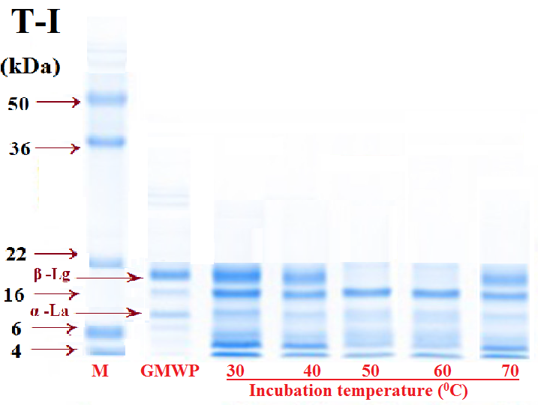
Fig. 1A: T-I= Trypsin, SDS-PAGE for different incubation temperature, M= Protein molecular marker, GMWP=goat milk whey protein. | Fig. 1B: Trypsin NPN (mg/ml) for different incubation temperature, different small letters differ significantly (<0.05).

Optimization of incubation time
The hydrolysates of GMWP using trypsin enzyme was done at different incubation times from 30 to 300 min, and hydrolysis were compared with the standard molecular weight marker using SDS-PAGE analysis (Fig. 2A).
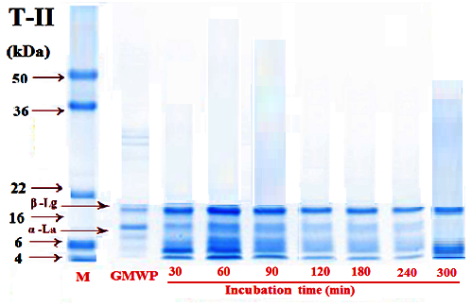
Fig. 2A: T-II= Trypsin, SDS-PAGE for different incubation time, M= Protein molecular marker, GMWP=goat milk whey protein. | Fig. 2B: NPN (mg/ml) for different incubation time, different small letters differ significantly (<0.05).

SDS-PASE showed that the hydrolysation of GMWP with trypsin enzyme was increased as the incubation time increased up to 180 min. These findings were further confirmed with NPN method (Fig. 2B). The non protein nitrogen was recovered up to 5.5 mg/ml at 180min. Fig 2A and 2B revealed that the hydrolysation of GMWP did not increase significantly (<0.05) after 180 min of incubation time with trypsin enzyme. Wang et al. (2020) also reported that camel milk whey protein were completely hydrolyzed and digested with trypsin enzyme for 180 min.

Optimization of incubation enzyme concentration
Different enzyme concentrations of trypsin enzyme from 0.25 to 2.0 percent level were used for hydrolysates of GMWP and hydrolysis were compared with the standard molecular weight marker using SDS-PAGE analysis (Fig.3A).
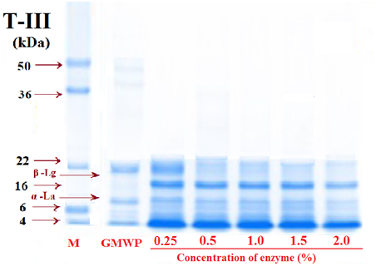
Fig. 3A: T-III= Trypsin, SDS-PAGE for different incubation Con., M= Protein molecular marker, GMWP=goat milk whey protein. | Fig. 3B: NPN (mg/ml) for different incubation Con., different small letters differ significantly (<0.05).
SDS-PASE showed that the hydrolysation of GMWP with trypsin enzyme was increased as the enzyme concentration increased up to 1.0 % level. These findings were further confirmed with NPN method (Fig. 3B). The non protein nitrogen was recovered up to 5.5 mg/ml at 1.0 per cent enzyme concentration. Fig 3A and 3B revealed that the hydrolysation of GMWP did not increase significantly (<0.05) after 1.0% level of enzyme concentration with trypsin enzyme. An enzyme concentration of trypsin was 1% at 37°C for 4 h also considered optimum for digestion of casein by Mir et al. (2018) in Silk.

Optimization of incubation pH
The hydrolysates of GMWP using trypsin enzymes was done at different incubation pH levels from 6 to 10, and hydrolysis were compared with the standard molecular weight marker using SDS-PAGE analysis (Fig. 4A).
SDS-PASE showed that the hydrolysation of GMWP powder with trypsin enzyme was highest at pH 8.0 level followed by 9.0 pH. These findings were further confirmed with NPN method (Fig. 4B).
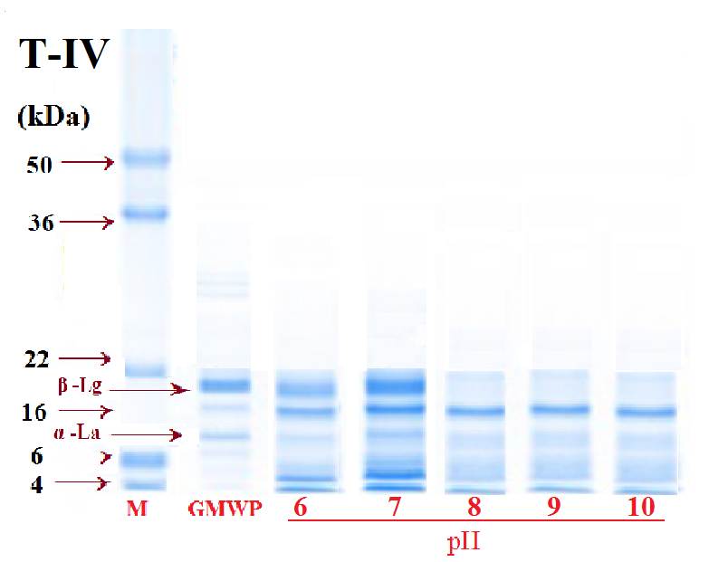
Fig. 4A: T-IV= Trypsin, SDS-PAGE for different incubation pH, M= Protein molecular marker, GMWP=goat milk whey protein. | Fig. 4B: NPN (mg/ml) for different incubation pH., different small letters differ significantly (<0.05).

The non protein nitrogen was recovered 5.7 mg/ml at 8.0 pH level, which was highest. Fig 4A and 4B revealed that the hydrolysation of GMWP was optimum at 8.0 pH level with trypsin enzyme. Mir et al., (2018) reported that trypsin is most active in the pH range between 7 and 9 at 37 ⁰C.
DH, ABTS and Ca⁺ chelating activity
The DH is a measure of the extent of hydrolytic degradation of a protein and is the most widely used indicator for comparing different proteolytic processes. Degree of hydrolysis and ABTS activity of goat milk whey protein hydrolysates by trypsin was expressed in terms of percentage (%) of hydrolysis carried out under different standardized control conditions selected for different enzymes (Table 1).
Table 1. The percent DH, ABTS and Ca⁺ chelating activity of GMWPH with trypsin
Proteolysis  time (Hrs) | Hydrolyzing enzymes Trypsin
 | DH (%) | ABTS | Ca+ Con. (%)
1 | 11.8ª±0.08 | 33.49ª±0.91 | 11.8ª±0.91
2 | 16.5^{b}±0.13 | 40.27^{b}±0.73 | 16.5^{b}±0.91
3 | 19.80^{c}±0.12 | 50.41^{c}±0.84 | 19.8^{c}±0.91
4 | 21.1^{dc}±0.09 | 52.68^{c}±0.69 | 21.1^{cd}±0.91
5 | 22.3de±0.14 | 52.49^{c}±1.02 | 22.3de±0.91
6 | 23.1e±0.13 | 51.88^{c}±0.77 | 23.1e±0.91
Mean±SE with different small letters superscripts column wise differ significantly (p≤0.05)
DH for each enzyme increased with increase in time of hydrolysis from 1 hr to 6 hrs. It was observed that trypsin enzyme till 4 hrs (21.1%) produced peptides with increased degree of hydrolysis significantly, but after these selected times, there was no significant increase in DH of the entire enzymes. Kumar et al. (2016) also reported that the rate of DH increased linearly up to 2 h; thereafter, the rate of DH decreased and, subsequently, it got stabilized in camel milk casein hydrolyses with different enzymes. The reduction in hydrolysis rate over time may indicate the decreased availability of cleavable peptide bonds within the substrate.
The ABTS radical-scavenging activity increased significantly (P<0.05) with the advancement of hydrolysis time up to 4 hrs for trypsin GMWPH. Similar reports were documented by Kumar et al. (2016). These findings were also in accordance with the findings of Salami et al. (2011) who also reported higher antioxidant activity of camel milk casein hydrolysates upon digestion with gastrointestinal enzymes.
These results indicated that the degree of hydrolyzation by trypsin enzyme treatment influences the Ca-chelating activity within 4 hrs of the obtained GMWPH. After that, DH and Ca-chelating activity did not increase significantly in trypsin treated hydrolysates. If the hydrolysis time was prolonged after 4 hrs, there was no significant further increase in Ca-chelating ability, which meant that DH played an important role in the chelating reaction between GMWPH and Ca ions. Xixi et al (2015) also indicate that the degree of enzyme treatment influences the Ca-chelating activity of the obtained WPH. A similar result was reported that yak casein hydrolysate had highest Zn-chelating capacity at DH 22.8 % and if the hydrolysis time was too long, the Zn-chelating ability decreased (Fiorillia et al., 2009). Zhao et al. (2014) explained that the major binding sites included oxygen atom of the carbonyl group and nitrogen of amino group or imino group; structural modifications of the peptide arose with the addition of calcium ion. Saini et al. (2014) found that calcium binding ability of CPPs was 0·934 mg calcium/mg of CPPs. Corsetti et al. (2003) observed that the calcium binding ability of CPPs isolated from various species varies from 0·4 to 1·4 mg calcium/mg CPPs. Their results also showed that goat milk hydrolysates have higher calcium binding activity than human and sheep milk.

CONCLUSION
Hydrolysis of goat milk whey protein with trypsin resulted in a significant increase in antioxidant and Ca⁺ chelation property. Hence, the GMWPH may be useful for development of novel foods for infants, and the elderly osteoporosis patients to replace cow milk hydrolysates.

REFERENCES
Agnihotri, M. K., and Prasad, V. S. S. (1993). Biochemistry and processing of goat milk and milk products. Small Ruminant Research, 12(2), 151-170.
Anderson, J.J.B. and Garner, S.C. (1996). Calcium and phosphorous nutrition in health and disease: Introduction. In: Calcium and Phosphorous in Health and Disease. CRC Press: New York, NY, Pp. 1–5.
AOAC. (2007). Official Methods of Analysis. 18th ed. Association of Official Analytical Chemists, Washington DC.
Balk, E. M., Adam, G. P., Langberg, V. N., Earley, A., Clark, P., Ebeling & Dawson-Hughes, B. (2017). Global dietary calcium intake among adults: a systematic review. Osteoporosis International, 28(12), 3315-3324.
Beulens, J. W., Bindels, J. G., De Graaf, C., Alles, M. S., &Wouters-Wesseling, W. (2004). Alpha-lactalbumin combined with a regular diet increases plasma Trp–LNAA ratio. Physiology &behavior, 81(4), 585-593.
Diaz-Castro, J., Perez-Sanchez, L.J., Lopez-Frias, M.R. and Lopez-Aliaga, I. (2011). Influence of cow or goat milk consumption on antioxidant defense and lipid per oxidation during chronic iron repletion. The British J. Nutri.108(1): 1-8. DOI: 10.1017/S0007114511005204.
Graveland-Bikker, J. F., Schaap, I. A. T., Schmidt, C. F., & De Kruif, C. G. (2006). Structural and mechanical study of a self-assembling protein nanotube. Nano letters, 6(4), 616-621.
Kalyan, S., Meena, S., Kapila, S., Sowmya, K., & Kumar, R. (2018). Evaluation of goat milk fat and goat milk casein fraction for anti-hypercholesterolaemic and antioxidative properties in hypercholesterolaemic rats. International Dairy Journal, 84, 23-27
Laemmli, U.K.(1970). Cleavage of structural proteins during assembly of the head of bacteriophage T4. Nature,277: 680–685.
Law A.J.R. (1995). Heat denaturation of bovine, goat and ovine whey proteins. Milchwissenschaft. 50: 384–388.
Livestock Census. 20thhttps://vikaspedia.in/agriculture/agri-directory/reports-and-policy-briefs/20th-livestock-census.
Markus, C. R., Jonkman, L. M., Lammers, J. H., Deutz, N. E., Messer, M. H., &Rigtering, N. (2005). Evening intake of α-lactalbumin increases plasma tryptophan availability and improves morning alertness and brain measures of attention. The American journal of clinical nutrition, 81(5), 1026-1033.
Smithers, G. W. (2008). Whey and whey proteins—from ‘gutter-to-gold’. International Dairy Journal, 18(7), 695-704
Xixi, C., Lina, Z., Shaoyun, W., &Pingfan, R. (2015). Fabrication and characterization of the nano-composite of whey protein hydrolysate chelated with calcium. Food & function, 6(3), 816-823.
Yan, L. I., Hai-yan, S. U. N., Li-zhen, Z. H. O. U., & Dong, L. I. U. (2014). Optimization of purification process of angiotensin converting enzyme inhibitor peptide VLPVPR with macroporous resin. 业科技, (06), 206-211.
Zhao, L., Cai, X., Huang, S., Wang, S., Huang, Y., Hong, J., & Rao, P. (2015). Isolation and identification of a whey protein-sourced calcium-binding tripeptide Tyr-Asp-Thr. International Dairy Journal, 40, 16-23.

