Clinical article
DICEPHALUS TRIBRACHIUS DIPUS DICAUDATUS MONSTER IN A JERSEY CROSSBRED COW
M. Periyannan, M. Selvaraju*, V. Varudharajan, A. Fazil, D. Gopikrishnan and
K. Senthilkumar
Department of Veterinary Gynaecology and Obstetrics
Veterinary College and Research Institute
Namakkal – 637 002
Tamil Nadu Veterinary and Animal Sciences University
*Corresponding author: drmselvaraju1969@gmail.com

SUMMARY
An unusual case of dystocia due to dicephalus tribrachius dipus dicaudatus fetal monster in a Jersey crossbred cow is reported.
Keywords: Dystocia, Monster, Double head, Cow.
During early embryonic development, certain factors such as physical, chemical and viral infections were response for occurrence of fetal anomalies (Prabaharan et al., 2013). Fetal anomalies and monstrosities are common cause of dystocia in bovines and it may or may not interfere the fetal delivery (Alagar et al., 2018). The occurrence of double headed monster was reported more frequently in ruminants (Thangadurai and Selvaraju, 2015). The present case documents the pervaginal delivery of a dicephalus (double headed) tribrachius (three fore limbs) dipus (two hind limbs) dicaudatus (double tailed) fetal monster. Hence, this present investigation report successful management of double headed monster in a Jersey crossbred cow.
A pluriparous Jersey crossbred cow was brought to TVCC, VCRI Namakkal for fetal delivery. The animal calved twice earlier without any obstetrical complication. Further, owner reported that the water bag was ruptured 8 hours ago and unsuccessful attempt was made by field veterinarian to deliver the fetus. On clinical examination the rectal temperature was 38.5°c, respiration and heart rate was found to be normal. The animal was in sternal recumbency and it was dull and depressed. Vaginal examination revealed complete cervical dilatation and the fetus was found to have two heads and it was fused at the level of neck
*Corresponding author: drmselvaraju1969@gmail.com

region; Presentation of the fetus was anterior longitudinal (P1), position was left dorso-iliac (P2) and both the fore limbs extended towards the birth canal and hence the case was diagnosed as double headed monster.
The cow was restrained in hind quarter elevator on its left lateral recumbency under epidural anesthesia with 3 ml of 2% lignocaine hCl and 10 litres of lukewarm water was infused into the uterus. Then both the fore limbs were secured with nylon rope and it was repelled inside the uterus one by one dorsolateral to the fetus. Long obstetrical eye hook was applied in left inner canthus of one head and right inner canthus of another fetus. By two men cross traction head was brought outside the vulva and both the fore limbs were extended from the uterus and free ends of the snares were connected with calf puller and double headed monster was delivered without damaging the birth canal. Post-operatively animal was treated with inj. Calcium borogluconate (450 ml), Dextrose 25% (1 litre) and inj. Ceftriaxone (6 g) by intravenous route and inj. Flunixin meglumine (400 mg) and Chlorpheniramine maleate (120 mg) was given intramuscularly. The cow recovered successfully following the treatment and the owner was advised to supplement the oral herbal uterotonic preparation to boost uterine involution.
Gross examination of the monster revealed optimal growth of the fetus with respective stage of gestation and it had two head (Dicephalus), two symmetrical and one asymmetrical fore limb (Tribrachius), two hind limbs and two tails (Dicaudatus). Post-mortem examination of the monster showed the duplication up to the level mid oesophageal region.
The dystocia due to dicephalus monster was reported by Thangadurai and Selvaraju (2015) in a buffalo and Chandrahasan et al. (2003) and Acharya et al. (2019) in cows. Fetal anomalies always makes delivery as difficult and most commonly required fetotomy or caesarean section but pervaginal delivery was reported by Thangadurai and Selvaraju (2015) in a buffalo. In the present case, the monster fetus was smaller than the inner pelvic surface area and it might be the reason for the successful vaginal delivery.
REFERENCES
Acharya, C., Kalita, M. K., Mahanta, Chhetri, N. B., Barman, U. (2019). Dystocia due to a Dicephalus Monster Fetus in Holstein Friesian Cow. Int. J. Curr. Microbiol. App. Sci. 8(2): 3024-3027.
Alagar, S., Velladurai, C., Selvaraju, M. (2018). Successful pervaginal delivery of rare fetal monster in jersey crossbred cow. Indian Vet. J. 95(09): 54-55.
Chandrahasan, C., Krishnakumar, K., Selvaraju, M., Richard Jagannathan, P.N., Ramesh Sarvanana Kumar, V. (2003). Dystocia due to Dicephalus monstonus monster in a crossbred cow. Indian J. Ani. Reprod. 24(2):175
Prabaharan, V., Jayakumar, K., Kathirvel, S., M. Selvaraju M., Dharmaceelan, S. (2013). Dystocia due to bull dog calf in a non-descript buffalo. Shanlax Int. J. Vet. Sci. 1(1): 43-44.
Thangadurai, R. and Selvaraju, M. (2015). Dystocia due to double headed monster fetus in Murrah buffalo under field condition. Indian Vet. J. 92(11): 61-62.
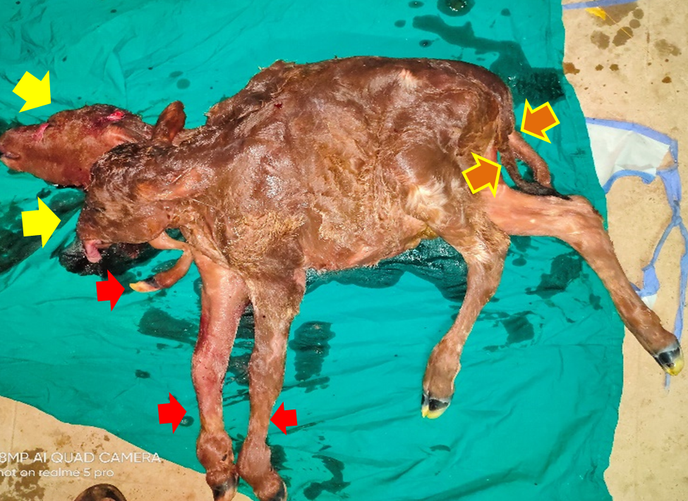
Fig. 1 Dicephalus tribrachius dipus dicaudatus fetal monster

