MOLECULAR STUDIES ON HEPATOINTESTINAL SCHISTOSOMES IN CATTLE (BOVINES)
B. M. MANOHARA¹, PLACID E. D’SOUZA², G. S. MAMATHA³ AND H. DHANALAKSHMI^{4*}
Department of Veterinary Parasitology, Veterinary college, Bengaluru 560024, Karnataka, India
Address: ¹MVSc scholar (manoharvet@gmail.com), ² Professor and Head (Retd.) (placid536@gmail.com), ³Assistant professor (drmamathaags@gmail.com), ^{4*Corresponding Author} Assistant professor and Head (dhanu.hanumappa@gmail.com), Department of Veterinary Parasitology.

ABSTRACT
A molecular study was carried out on hepatointestinal schistosomes in cattle for characterization of species. The worms were recovered from the liver and mesentery from the cattle slaughtered at the abattoir from Bengaluru and Hassan district. Polymerase chain reaction was carried out for Schistosoma worms by targeting genus specific 12S ribosomal RNA and cytochrome oxidase subunit I and species specific mitochondrial gene (SPMit) for S. spindale and SI16S RNA for Schistosoma indicum. All the isolates yielded 328 and 1088 bp DNA fragments specific for Schistosoma genus and 330 bp specific to S. spindale. No specific amplification was obtained for S. indicum. The sequencing and BLAST analysis of 328 bp amplicon showed homology with S. spindale isolates deposited at GenBank database. Phylogenetic analysis indicated that S. spindale Karnataka isolate (Accession no. MG052937) shared 100 per cent homology with isolate of S. spindale from Sri Lanka (EF534282).
Key words: S. spindale, mesentery, liver, abattoir, PCR and cattle
INTRODUCTION
Schistosomosis in bovines is widely reported as a disease entity in many parts of Asia and Africa. Schistosomosis is one of the most prevalent infectious diseases, endemic in more than 70 countries, mainly within the developing world (Hovnanian et al., 2010). About 530 million of cattle live in areas endemic for bovine schistosomosis in Africa and Asia while at least 165 million cattle are infected with schistosomes worldwide (Bont and Vercruysse, 1997). Schistosomosis is now well recognized as the fifth major helminthosis of domestic animals in the Indian sub-continent. Identification of worms based on phenotypic may be difficult due to overlapping of the characters viz., length of ﬂukes, intestinal caeca and number of testes. Molecular techniques based on genomes are very useful for the epidemiological diagnosis as well as for research on genetic variation of the parasitic organism. Hence, the present study was undertaken for the molecular characterization of the worms.
MATERIALS AND METHODS
Extraction of genomic DNA
The collected worms from liver and mesenteries were subjected to DNA extraction. The DNA was extracted from the worms using QIA amp DNA extraction mini kit (Qiagen, Germany) as per the protocol described by the manufacturer.
Polymerase chain reaction
A total reaction volume of 25 μl pre mixture of PCR consisting of two micro litre of forward primer, two micro litre of reverse primer, five micro litre of template DNA and 12.5μl of PCR master mix (2X) (Genei Laboratories Pvt ltd) and 3.5 μl of NFW was constituted.
The PCR was carried out in a gradient thermal cycler (Eppendorf, Germany) programmed for genus specific Schistosoma primers. No template control was maintained without a DNA template. DNA extracted from the blood containing Babesia organisms was used as a negative control. S. spindale DNA obtained from Dr. Sreenivasa murthy, Department of Veterinary Parasitology, Veterinary College, Hyderabad was used as positive control.
Sequence alignment and phylogenetic analysis
The PCR products of 12S ribosomal RNA (rrnS) gene of Schistosoma species were sequenced at M/s Bioserve biotech, Pvt Ltd, Hyderabad. The BLAST analysis for the obtained sequences was performed on GenBank database at National Centre for Biotechnologies Information (NCBI) on the website www.ncbi.nlm.gov/ BLAST. The sequences were aligned with the published sequences deposited in the GenBank database and the phylogenetic tree was constructed by maximum likelihood method with 1000 bootstrap replicates using MEGA 6.0 software (Tamura et al., 2013).
RESULTS AND DISCUSSION
Polymerase chain reaction
PCR was carried out by targeting Schistosoma genus specific 12S rrnS, COI and species specific SPMit and SI16sRNA genes. All the isolates yielded 328 (Fig.1 and Fig.2) and 1088 bp (Fig.3 and Fig.4) DNA fragments specific for Schistosoma genus and 330 bp (Fig.5 and Fig.6) specific to S. spindale. No specific amplification was obtained for S. indicum. Genus specific 328 bp amplicon of both Bengaluru and Hassan isolates were selected and were subjected for nucleotide sequencing. The sequencing and BLAST analysis of 328 bp amplicon showed homology with S. spindale isolates deposited at GenBank database. Phylogenetic analysis showed that S. spindale Karnataka isolate (Accession number MG052937) (Fig. 7) shared 100 per cent homology with isolate of S. spindale from Sri Lanka (EF534282) and 99 per cent with S. spindale isolate from Bangladesh (EF534281) and Nepal (KR607254).
The present findings were in agreement with the immunological and molecular studies on cattle and buffaloes in Bengaluru conducted by Sreenivasa murthy (2011) who reported S. spindale, S. indicum and S. nasale in Bengaluru based on PCR. Sreenivasa murthy (2011) detected and differentiated S. spindale, S. indicum, S. nasale by using 12S rrnS and COI genus specific primers which yielded 328 bp and 1088 bp DNA fragments and these products were sequenced and analysed by NCBI database for the species confirmation and phylogenetic tree was constructed. Similar work was carried out by Lakshmanan (2014) from Kerala and Hossain et al. (2015) from Bangladesh.
In this study, the phylogenetic analysis 12S rrnS of S. spindale Karnataka were in the same clade as S. spindale isolate from Sri Lanka deposited in the GenBank (EF534282) and shared 100 per cent identity and also shared 99.99 per cent identity with S. spindale from Bangladesh (EF534281) and Nepal (KR607254). Sreenivasa murthy (2011) from Bengaluru had reported that phylogenetic analysis of 12S ribosomal rRNA showed that S. spindale was related to distinct cluster of S. nasale from Bangladesh with 660 nucleotide substitutions. Similarly, Lakshmanan (2014) from Kerala reported that phylogenetic analysis of 28S rRNA of S. spindale from Kerala shared 100 per cent identity with S. spindale from Sri Lanka (AY157257). However, further research work is needed to know the prevalence of Schistosoma spp. in other regions of Karnataka and to implement proper control measures.
ACKNOWLEDGEMENTS
This paper is a part of the MVSc thesis submitted to KVAFSU, Bidar by the first author. The facilities and support extended by the ICAR, CAFT in Veterinary Parasitology, Veterinary College, Bengaluru is gratefully acknowledged.
REFERENCES
Attwood, S. W., Fatih, F. A., Fondal, M. M., Alim, M. A., Fadjar, S., Rajapakse, R. P. and Rollinson, D. A. (2007). DNA sequence-based study of the Schistosoma indicum (Trematoda: Digenea) group: population phylogeny, taxonomy and historical biogeography. Parasitol, 134 (14): 2009–20.
Bont, J. D. E. and Vercruysse, J. (1997). The epidemiology and control of cattle schistosomosis. Parasitol. Today, 13: 255-262.

Hossain, M. S., Begum, N., Rima, K. U., Dey, A. R. and Khan, A. H. N. L. (2015). Morphologic and molecular investigation of schistosomes from the mesenteric vein of slaughtered cattle. J. Agri. Vet. Sci, 8(5): 47-53.
Lakshmanan, B. (2014). Development of improved diagnostics for detection of bovine intestinal schistosomosis. Phd thesis submitted to K.V.A.S.U, Thrissur, Kerala, unpublished.

Sreenivasa Murthy, G. S. (2011). Immunological and molecular studies on schistosomes of cattle and buffaloes. PhD thesis submitted to K.V.A.F.S.U, Bidar, Karnataka, unpublished.
Tamura, K., Stecher, G., Peterson, D., Filipski, A. and Kumar, S. (2013). MEGA 6: Molecular Evolutionary Genetics Analysis version 6.0. Molecular boil. Evolution, 30: 2725-2729.
Hovnanian, A., Hoette, S., Fernandes, C. J. C., Jardim, C. and Souza, R. (2010). Schistosomosis associated pulmonary hypertension. The International Journal of Clinical Practice, 165.

Table 1: PCR cyclical conditions for Schistosoma genus (Sreenivasa murthy, 2011)
Initial denaturation | Denaturation | Annealing | Extension | Final extension
94 ° C for 5 min | 94 ° C for  30 sec | 50° C for  1 min | 72 ° C for  1 min | 72 ° C for 10 min
 | Repeated for 39 cycles
Table 2: PCR cyclical conditions for Schistosoma spindale (Hossain et al., 2015)
A total of 35 cycles of PCR amplification reactions were carried out for Schistosoma species.
Initial denaturation | Denaturation | Annealing | Extension | Final extension
95 ° C for 5 min | 95 ° C for  1 min | 54 ° C for  1 min | 72 ° C for  1 min | 72 ° C for 10 min
 | Repeated for 35 cycles
Table 3: PCR cyclical conditions for Schistosoma indicum (Hossain et al., 2015)
Initial denaturation | Denaturation | Annealing | Extension | Final extension
95 ° C for 5 min | 95 ° C for  1 min | 52 ° C for  1 min | 72 ° C for  1 min | 72 ° C for 10 min
 | Repeated for 35 cycles
Finally, PCR products were analyzed by electrophoresis in 1.5% agarose gel, stained with ethidium bromide and examined under UV light.

Table 4: Primers and their sequences used for generic identification of Schistosoma
blood flukes

Name of primer | Primer sequences(5´-3´) | Amplicon size | Targeted gene
SrrnS-F | TCGAGATTGTCGGGCGATGTAC | 328 bp | 12S rRNA
SrrnS-R | TAGATTCGTCCGGGGGAATGTGC
SCOI-F | GGTGGATTTATAGGTCTTGGGTTAAG | 1088 bp | cytochrome oxidase subunit I
SCOI-R | TCACAAATGGCCACCACCAAACCAACATTA  (Sreenivasa murthy, 2011)

Table 5: Primers and their sequences used to identify Schistosoma species
Name of primer | Primer sequences(5´-3´) | Amplicon size | Targeted gene | Species of Schistosoma
SPMitF | CTTGGAGTCGGGTTGTTTGAG | 330 bp | Mitochondrial gene | S. spindale
SPMitR | CAGACCCTCACACCAACAGTG  (Bindu et al.,2013)
SI6sRNAF | GAGTTTGTAAATGGAGGCTGAG | 606 bp | 16sRNA | S. indicum
SI16sRNAR | CCTTATTCAGCCTCTACACCG  (Attwood et al., 2007)

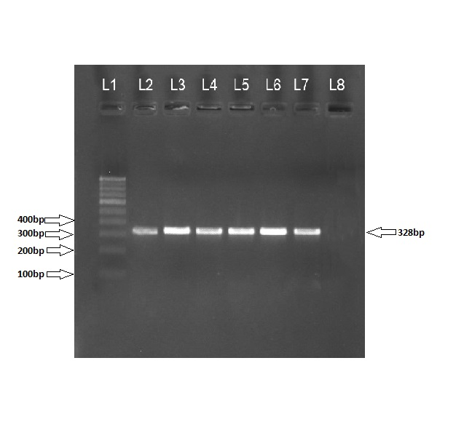
Fig 1: PCR analysis of 12S ribosomal RNA (rrnS) Fig 2: PCR analysis of 12S ribosomal RNA (rrnS) of of S. spindale (Bengaluru isolates) S. spindale (Hassan isolates)
L1: 100 bp ladder; L2: positive control; L3, L4, L5, L6 and L7: Samples of S. spindale; L8: negative control.
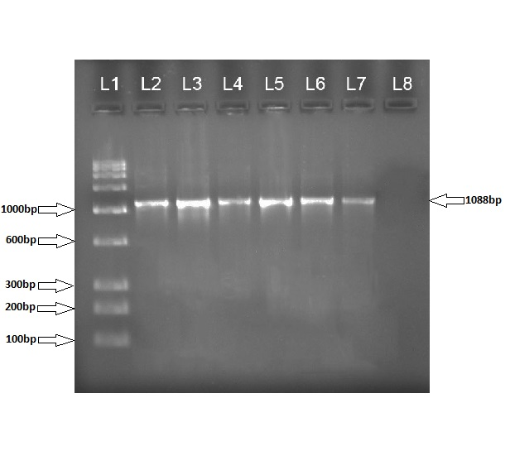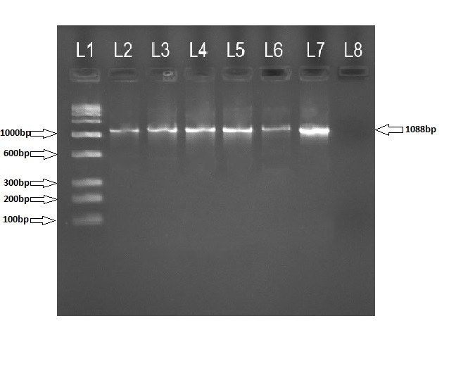
Fig 3: PCR analysis of COI gene of S. spindale Fig 4: PCR analysis of COI gene of S. spindale of Bengaluru isolates of Hassan isolates

L1: 3.5 kb ladder; L2: positive control; L3, L4, L5, L6 and L7: Samples of S. spindale; L8: negative control.
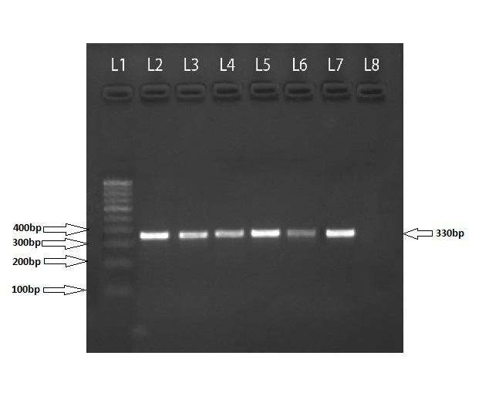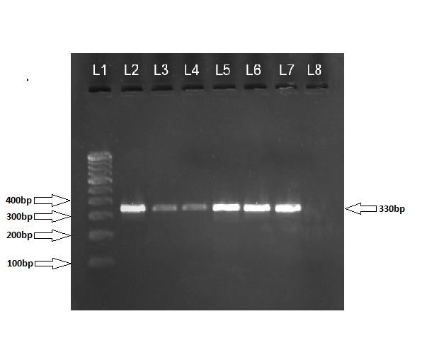Fig 5: PCR analysis of mitochondrial gene (SPMit) Fig 6: PCR analysis of mitochondrial gene (SPMit) of S. spindale (Hassan isolates) S. spindale (Bengaluru isolates)
L1: 100 bp ladder; L2: positive control; L3, L4, L5, L6 and L7: Samples of S. spindale; L8: negative control.

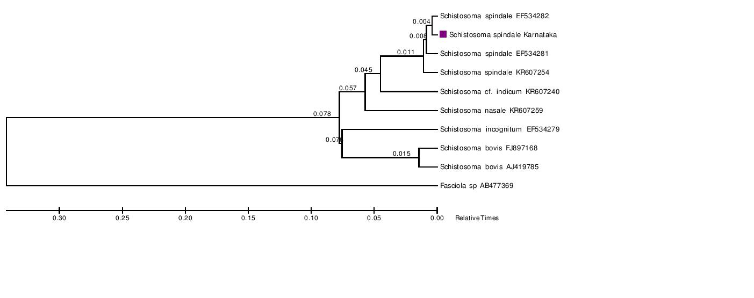
Fig 7: Phylogenetic analysis of 12S ribosomal RNA (rrnS) gene nucleotide sequence of
Schistosoma spindale

