Therapeutic management of Canine Compulsive Disorder (CCD) in a Pug: A Case Report
Pankaj Kumar Patel, Sonam Bhatt, Babul Rudra Paul, Sumit Kumar, S. K. Dixit, Sumit Mahajan and Akhilesh Kumar*
Division of Medicine, ICAR-Indian Veterinary Research Institute, Izatnagar-243122, India
*Corresponding author: Akhilesh Kumar

Abstract
A male pug dog aged 14 month was presented to the Referral Veterinary Polyclinic, IVRI Izatnagar with complaint of continuous circling, tail chasing and altered behavioral pattern. The systematic investigation did not show any significant abnormality in the haemato-biochemical parameters. Skin scrapping of tail was found negative for any ectoparasites.The institution of treatment of dog with clomipramine along with supportive therapy brought successful recovery in 4 weeks.
Key words: Circling, Canine Compulsive Disorder, Clomipramine, Pug

INTRODUCTION
Canine-compulsive disorder (CCD) are frequent sequel to compulsive component (finding repetitive, stereotypic motor, locomotory and hallucinogenic behaviors) characterized by frequency or duration in excess circling, tail chasing, flank sucking, fence running, fly biting, self mutilation, hair or air biting, pica, pacing or spinning, staring, aggressions, self-directed vocalizing, and fabric sucking or chewing that interfered with the animal’s ability to function in its social environment. CCD commonly appears between pre-pubescence and early social maturity which could be aggravated by anxiety or stress. Further, in due course of time such stereotypic behaviour becomes ‘fixed’ and become evident even in the absence of any obvious stressors (Overall and Dunham, 2002; Kumar et al., 2012; Tang et al., 2014).

Signalment
A 14 month old, male Pug dog was presented to the Referral Veterinary Polyclinic, ICAR-Indian Veterinary Research Institute, Izatnagar, Bareilly (U.P) with history of circling, biting, chasing of tail (Fig.1) and viciousness along with altered behavior. The dog was dewormed and vaccinated as per standard regimen.
Clinical examinations and laboratory findings: All the haemato-biochemical (Table .1) parameters are in normal range. Skin scrapping was negative for ectoparasites and no any wound is present on the coat. Differential diagnoses was done through questionnaire of other behavioral condition originate from environment, management, humane considerations (eg, those involving understimulation, neglect, or excessive confinement), separation anxiety, attention-seeking behavior, generalized anxiety, and hyperactivity (Overall and Dunham, 2000).

Fig.1: Circling and Tail chasing
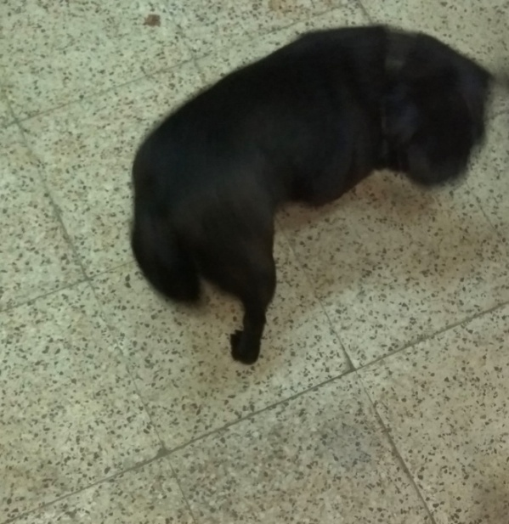

Table.1: The haemato-biochemical parameters of affected dog
Parameter | Reference range* | 0 day
Hb (g/dl) | 11.9-18.9 | 13.6
PCV (%) | 24-46 | 37
TEC (10⁶/cmm) | 4.95-7.87 | 5.27
TLC (10³/cmm) | 5.0- 14.1 | 8.53
Neutrophils % | 58-85 | 76
Lymphocytes % | 8-21 | 18
Monocytes% | 2-10 | 2
Eosinophils% | 0-9 | 2
Basophil% | 0-1 | 0
Platelet count (10⁶/cmm) | 211-621 | 412
SGPT(U/L) | 10-109 | 28
SGOT (U/L) | 13-15 | 23
BUN (mg/dl) | 8-28 | 13
Creatinine(mg/dl) | 0.5-1.7 | 0.4
Total Protein (mg/dl) | 5.4-7.5 | 7.2
Albumin (mg/dl) | 2.3-3.1 | 3.0
Globulin (mg/dl) | 2.7-4.4 | 4.2
(*Source: (Merck Veterinary Manual, 11th Edition )

Treatment
Treatment was instituted with Clomipramine @1 mg/kg, PO, BID for 14 days followed by 2 mg/kg, PO, BID for next 14 days along with supportive therapy of Hepato-protectants and proton pump inhibitor (Omeprazole) @ 0.5 mg/kg PO, once a day for 4 weeks.
Result and Discussion
A repetitive and unruly behavior without an apparent goal is pets are being frequently recorded. The appearance of such stereotypy is suggestive of improper welfare, changed environment, social separation or and/or the result of nervous dysfunction. Recently, the highly significant association of CCD with the CDH2 region on chromosome 7 of Doberman pincher has been established (Dodman et al., 2010). The repetitive behaviors interfere with the daily functioning of their dogs, preventing them from being able to eat, play, and interact normally with people (Overall & Dunham, 2002). Stereotypic behaviors may or may not be associated with CCD and it appears during the period of social maturity (Hewson et al., 1999 and Overall and Dunham, 2000). Similar to CCD, obsessive compulsive disorder (OCD) is result of abnormal serotonin metabolism in human (Murphy, 1990). Hence, clomipramine a tricyclic antidepressants (TCA) which targets the serotonergic metabolism were found useful in the management of CCD (Overall and Dunham, 2000). Similarly, fluoxetine, a selective serotonin reuptake inhibitor at the dose rate of 1 to 2 mg/kg, PO daily for 7 weeks was found effective in reducing the severity of CCD in affected dogs (Irimajiri et al., 2009). To reduce chance of gastrointestinal disorder which have been generally seen after clomipramine treatment, the gradual increase in dosage of clomipramine (1 mg/kg, PO, BID for 14 days, then 2 mg/kg, PO, BID for next 14 days (King et al., 2000) and in present case administration of omeprazole to diminishing gastric acidity (Patel et al.,2018). OCD is generally associated with elevated blood cholesterol level, so it can be managed with hepatotonics medicine and avoidance of lipid diet to the dog (Kumar et al., 2012).

Conclusion
Stereotypic behavior of excess circling in own axis and tail chasing without an apparent goal is a one type of Canine Compulsive Disorder (CCD). Such cases can be successfully managed by Clomipramine along with supportive therapy and proper nursing care and management.

References
Dodman, N.H., Karlsson, E.K., Moon-Fanelli, A., Galdzicka, M., Perloski, M., Shuster, L., Lindblad-Toh, K., and Ginns, E. I. (2010). A canine chromosome 7 locus confers compulsive disorder susceptibility. Mol Psychiatry. 15(1):8-10.
Hewson, C.J., Luescher, U.A., and Ball, R.O. (1999). The use of chance corrected agreement to diagnose canine compulsive disorder: an approach to behavioral diagnosis in the absence of a ‘gold standard’. Can. J. Vet. Res. 63: 201–206.
Irimajiri, M., Luescher, A.U., Douglass, G., Robertson-Plouch, C., Zimmermann, A., and Hozak, R. (2009). Randomized, controlled clinical trial of the efficacy of fluoxetine for treatment of compulsive disorders in dogs. J. Am. Vet. Med. Assoc. 235(6): 705-709.
King, J.N., Simpson, B. S., Overall, K.L., Appleby, D., Pageat, P., Ross, C., and Muller, G. (2000). Treatment of separation anxiety in dogs with clomipramine: results from a prospective, randomized, double-blind, placebo-controlled, parallel-group, multicenter clinical trial. Appl. Anim. Behav. Sci. 67(4): 255-275.
Kumar, A., Dar, A.A., Singh, S.K., Ansari, A.A. and Dey, S. (2012). Tail chasing in a German shepherd dog: A compulsive obsessive disorder. I. J. Vet. Med. 32(1): 52-53.
Merck Veterinary Manual. 11th Edition, Merck & Co., Inc. Kenilworth, NJ, USA.
Murphy, D. L. (1990). Neuropsychiatric disorders and the multiple human brain serotonin receptor subtypes and subsystems. Neuropsychopharmacology.
Overall, K.L., and Dunham, A.E. (2002). Clinical features and outcome in dogs and cats with obsessive-compulsive disorder: 126 cases (1989–2000). Journal of the J. Am. Vet. Med. Assoc. 221(10): 1445-1452.
Patel, P.K., Patel, S.K., Dixit, S.K., and Rathore, R.S. (2018). Gastritis and Peptic Ulcer Diseases in Dogs: A Review. Int. J. Curr. Microbiol. App. Sci. 7(3): 2475-2501.
Tang, R., Noh, H.J., Wang, D., Sigurdsson, S., Swofford, R., Perloski, M., and Auton, A. (2014). Candidate genes and functional noncoding variants identified in a canine model of obsessive-compulsive disorder. Genome Biol. 15(3): R25.

