**ULTRASONOGRAPHIC EVALUATION OF HEALING PROCESS OF TEAT FISTULA REPAIR USING POLYGLACTIN 910 SUTURE MATERIAL AND ISO – BUTYL CYANOACRYLATE TISSUE ADHESIVE IN BOVINES**

SUKHDEV SINGH1*, R. S. BISLA2, ASHOK KUMAR3, NEERAJ ARORA3, AND MOHIT JAMDAGNI1

1 M.V.Sc. Research Scholars, 2 Regional Director cum Principal Scientist, 3Professor and Head Department, 4Assistant Professor

Department of Veterinary Surgery and Radiology, College of Veterinary Sciences,

Lala Lajpat Rai University of Veterinary and Animal Sciences, Hisar

**ABSTRACT**

The study was conducted on 18 clinical cases of teat fistula in bovines with the objective of diagnosis of teat fistula severity in terms of tissue damage and evaluation of healing process through ultrasonographic examination. The study was conducted under three groups, and in all three groups mucosal layer was sutured with 3-0 Polyglactin 910 and in group A and B muscular layer was sutured with 3-0 Polyglactin 910 whereas skin was sutured with 2-0 silk and adhered with Iso- butyl cyanoacrylate in group A and B, respectively. In group C muscular and skin layer were adhered using Iso-butyl cyanoacrylate. Preoperatively on day 0, the teat fistula severity and tissue damage was diagnosed by ultrasonography examination (change in echogenicity pattern). Group B protocol found better in the treatment of teat fistula in terms of healing and aesthetic value of teat.

**Key words:** Bovines, Iso- butyl cyanoacrylate, Polyglactin 910, Teat fistula, Ultrasonography.

India ranks first in world in milk production but productivity are very low in comparison to developed countries. Among various reasons of reducing productivity, different teat affections viz. teat stenosis, teat injury, teat fistula, lactoliths, teat ulcers, and mastitis have a vital role (Schukken *et al.,* 1992). Hence, a better understanding of udder and teat affections and abnormalities is highly needed. Teat fistula is one of the most common causes of mastitis in domestic animals (Nichols *et al.,* 2016) and needs a timely diagnosis and treatment not only to prevent milk loss but also keep the udder health in optimum condition. Repair of teat fistula is a challenging factor due to continuous milk flow in teat canal and prevalence of leakage of milk in teat muscle through suture line which further develops the condition of non union and infection. Tissue adhesive (Iso- butyl cyanoacrylate) having the nature of sealing the suture line improve healing by preventing the leakage of milk in suture line. The present study was conducted to compare the healing process of teat fistula using different suture materials and tissue adhesive and the healing process was evaluated using ultrasonography.

**MATERIALS AND METHODS**

The study was conducted on 18 clinical cases of bovines presented to with history of leaking milk from right hind teat in eight cases and seven in left hind teat and rest of the affected teat are right and left fore teats, respectively out of 18 cases brought to Veterinary Clinical Complex, Lala Lajpat Rai University of Veterinary and Animal Sciences. Hisar. All the cases were divided into three groups of six animals each irrespective of the age and breed to evaluate the severity of injury to the teat and also the ultrasonographic evaluation of healing process on day 0, 7 and 15 postoperatively. In group A (n=6) the two inner layers (mucosal layer and muscular layer) were sutured using 3-0 Polyglactin 910 and the skin was sutured by using silk 2-0. In group B (n=6) the two inner layers were sutured using 3-0 Polyglactin 910 and skin was adhered using iso-butyl cyanoacrylate. In the group C (n=6) only the inner most layer was sutured using 3-0 Polyglactin 910 and other tissues including skin were adhered using iso-butyl cyanoacrylate. The operation was performed in lateral recumbency with the affected teat upwardside. The surgical site was prepared for aseptic surgery. After aseptic preparation of the site, xylazine (0.03 mg/kg intravenously) was administered and 2% lignocaine hydrochloride was infiltrated in a ring pattern at the base of affected teat. After proper local analgesia, reconstruction of teat fistula was done by three different protocols. The present investigation was conducted in vertical and horizontal plane with Siemens ACUSON X300 ultrasound machine with 6.2 to 10 MHz linear probe. The normal bovine udder and teat in four buffaloes and four cows were subjected to ultrasonographic examination for standardizing the technique and machine settings. The examination of the udder and teat was performed to scan various structures as per their topographical anatomy. The direct contact and water bath techniques were used for ultrasonography examination of teat for evaluation of healing process postoperatively. (Franz *et al.,* 2009).

**RESULTS AND DISCUSSION**

The ultrasonography of healthy animal’s teat was done by linear probe with 6.2 to 8 MHz frequency for standardization. The echogenicity pattern observed was as follow; skin revealed as hyperechoic, muscular layer– longitudinal and circular and conjunctive tissue layers- hypoechoic, blood vessel- hyperechoic, sub-mucosa and mucosal layer- hypoechoic, Furstenberg rosette- slightly hyperechoic and Teat canal revealed hyperechoic as thin, bright white line delineated on each side by parallel thick, dark, grey blank band (figure 1).The transition between teat cistern and gland cistern was done by annular fold and venous ring of Furstenberg which revealed by anechoic pattern near to annular fold (Figure 2).

In group **A**, five cases of teat fistula healed properly but in one case reoccurrence was observed due to infection in suture line area. Preoperatively on day 0, the teat fistula severity and tissue damage was easily diagnosed by ultrasonographic image (change in echogenicity pattern) (figure 4). On 7th day, hypoechoic image pattern was formed in the region of suture line area as depicted in ultrasonographic observation (figure 5). Gross examination on seventh day revealed that the fistula gap was completely filled up and suture was removed on seventh day. On 15th day of ultrasonographic observation revealed that the pattern of healing area was changed from hypoechoic to slightly hyperechoic (figure 7).Gross examination on 15th day revealed that complete healing with large scar and stitch marks (figure 6). In group **B**, five cases of fistulae healed properly but in one case reoccurrence occurred due to early sloughing off tissue adhesive scab. On 7th day, at the region of suture line hypoechoic and small dot pattern of hyperechoic image was formed in ultrasonographic observation (figure 8). Gross examination on seventh day revealed that the fistulae gap was completely filled up and a hard scab of tissue adhesive was formed on suture line. On 15th day of ultrasonographic observation, we found that the healing area was changed from hypoechoic to more hyperechoic (figure 10). The complete healing of teat fistula occurred on 15th day (figure 9) and scab was sloughed off on 18th day. In group **C**, reoccurrence occurred in all cases due to early slough off of tissue adhesive scab and leakage of milk through teat fistula. On 7th day, at the tract of fistulae region, interrupted pattern of small irregular hypoechoic and anechoic pattern was present in ultrasonographic observation (figure 12). Gross examination on seventh day confirmed that the fistulae gap was not completely filled up (figure 11). No healing occurred in this protocol.

Change in echogenicity pattern of teat wall was recorded to examine the severity of tissue damage in affected teat preoperatively, on day 0. Proportion of hypoechoic appearance, discontinuity of the hyperechoic outer teat wall and hypoechoic and anechoic irregular tubular appearance of fistulous tract denote tissue damage severity similar to Raj (2010). On 7th day in group A and B at the region of healing in teat wall, hypoechoic pattern with small hyperechoic dots were formed but in group C due to early sloughing of tissue adhesive scab no healing occurred and irregular hypoechoic tubular appearance was observed. The hypoechoic pattern was formed due to newly formed immature granulation tissue and small hyperechoic dot was formed due to starting of maturation of granulation tissue by deposition of collagen fiber. This is in agreement with findings of Mohafez *et al.* (2018). As compared to group A, more hyperechoic dots were present in group B which depict the early maturation of granulation tissue and early wound healing occurred. On the basis of this finding, tissue adhesive applied over the skin did not interfere between the skin edges, preserving the original structure leading to quicker reunion (Bresnahan *et al.,* 1995). In group C no healing occurred because tissue adhesive acts as barrier for epithelial healing since it is applied inside muscular and skin layer (Sangwan, 2003). Since only mucosal layer suturing was done in this group C and due to milk leakage through suture line, frequent exposure to moisture results in early tissue adhesive slough off. Singer *et al.* (2008) state that frequent exposure to moisture may result in adhesive failure. The cyanoacrylate topical skin adhesives should not be used in proximity to mucous membranes such as the mouth. Failure of group C also may occur due to development of high tension without suturing in muscles and skin. Singer *et al.* (2008) hypothesized that topical skin adhesives are not as strong as 3/0 and some 4/0 sutures. Therefore, when used alone, there is an increased risk of wound dehiscence with high-tension wounds. On 15th day observation in group A and B complete healing occurred and at healing region, in ultrasonographic images show more hyperechoic pattern in group B as comparison to group A which depicted that more maturation of granulation tissue occur and wound strength was increase by deposition of collagen fibers. This was found in consistent with findings of Mohafez *et al.* (2018).

Group B protocol provides better cosmesis when compared with group A, Arora (2002) similarly reported that skin closure Iso amyl 2- cyanoacrylate provided better cosmesis when compared with silk sutures. It was also observed that incisions closed with tissue adhesive were aesthetically pleasing and a single linear scar was produced. The use of the topical cyanoacrylate adhesives also reduces the risks of needle sticks (Gordon, 2001) and prevents the formation of suture marks on either side of the wound. Deolekar *et al.* (2017) also found that use of tissue adhesive has an advantage of cosmetically better scar when compared to conventional suturing.

Based on the observations of present study we can conclude that; in the present study, Ultrasonography is a good method for diagnosis of teat fistula in term of tissue damage and teat involvement. Combination of tissue adhesive and suture material was found to be superior when tissue adhesive was used only on skin in the correction of teat fistula as promotes healing and maintains aesthetic value of the teat.

**REFERENCES:**

Arora, A. (2002). Evaluation of Iso amyl- 2 cyanoacrylate (tissue adhesive) for closure of ventral abdomen skin incision in dogs. *M.V.Sc. thesis submitted to C.C.S.H.A.U.,* Hisar.

Bresnahan, K.A., Howell, J.M. and Wizovek, J. (1995). Comparison of tensile strength of cyanoacrylate tissue adhesive closure of lacerations versus suture closure. *Ann. Emer. Med.,* **26:** 575-579.

Deolekar, S, Thakur, B.A. and Bairolia, K. (2017). Comparison of conventional suturing and tissue adhesive (2-octyl cyanoacrylate) for port site skin closure in laparoscopic surgeries. *Int. Surg. J.,* **4:**204-8.

Franz, S., Floek, M. and Hoffmann-Parisot, M. (2009). Ultrasonography of the bovine udder and teat. *Vet Clin Food Anim Pract.* **25:** 669-685.

Gordon, C.A. (2001). Reducing needle-stick injuries with the use of 2-octyl-cyanoacrylates for laceration repair. *J. Am. Acad. Nurse Pract*., **13:** 10-2.

Mohafez, H., Ahmad, S. A., Hadizadeh, M., Moghimi, S., Roohi, S. A., Marhaban, M. H., Saripan,M. I. and Rampal, S. (2018). Quantitative assessment of wound healing using high-frequency ultrasound image analysis. *Skin Res. Technol.,* **24:**45–53.

Singer, A.J., Quinn, J.V and Hollander, J.E. (2008). The cyanoacrylate topical skin adhesives. *American Journal of Emergency Medicine.,* **26:** 490–496

Nichols, S., Babkine, M., Fecteau, G., Francoz, D., Mulon, P.-Y., Doré, E. and Desrochers, A. (2016). Long-term mechanical milking status of lacerated teat repaired surgically in cattle: 67 cases (2003–2013). *Can Vet J.,* **57(8):** 853–859.

Raj, H.P. (2010). Theloscopic and ultrasonographic evaluation of udder and teat and minimally invasive theloscopic surgery with bio-implant for milk flow disorders in dairy cows and buffaloes. *PhD Thesis submitted to Tamilnadu Veterinary and Animal Sciences University.* Chennai.

Sangwan, V. (2003). Tissue adhesive (iso-amyl-2 cyanoacrylate) in comparison to sub-cuticular sutures for closure of flank laparo-ovariohysterectomy skin incision in dogs. *M.V.Sc thesis submitted to CCSHAU,* Hisar.

Schukken, Y.H., Lesile, K.E., Weeersink, A.J. and Martin, S.W. (1992). Ontario bulk milk somatic cell count reduction program*. J. Dairy Sci.,* **75:** 3352-3358

For standardization of ultrasound machine four healthy cows and buffalo’s teat were scan with water bath and direct contact technique and normal images of teat taken as follows:

**Figure 1:** Normal ultrasonographic image of cow teat showing teat canal, Furstenberg rosette, skin, muscular and connective tissue and mucosal layer (Water bath technique; vertical scan; 8 MHz linear probe)

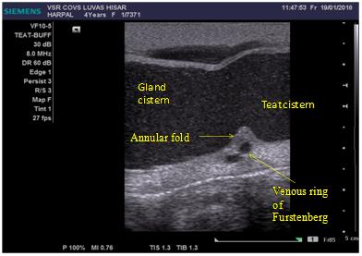

**Figure 2:** Ultrasonographic of transition between teat and gland cistern of bovine showing annular fold and venous ring of Furstenberg (Direct contact technique; vertical scan; 8 MHz linear probe)

**Comparative ultrasonographic evaluation of healing process of teat fistula**

**Group A**- The gross and ultrasonographic images of teat fistula on day 0, 7 and 15 as follow:

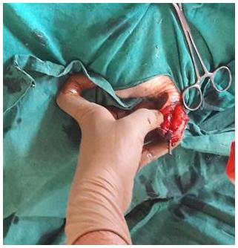

**Figure 3:**  Gross image of teat fistula on day zero preoperative (Group A)

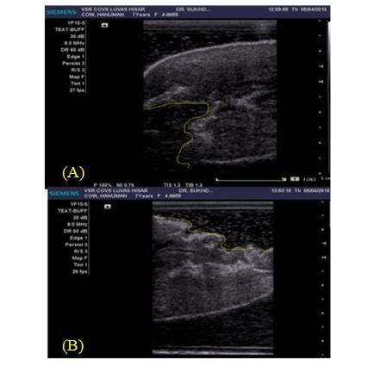

**Figure 4(A, B):** Ultrasonographic image of damage and loss of tissue of teat shown due to teat fistula (Water bath technique; vertical scan; 8MHz linear probe)

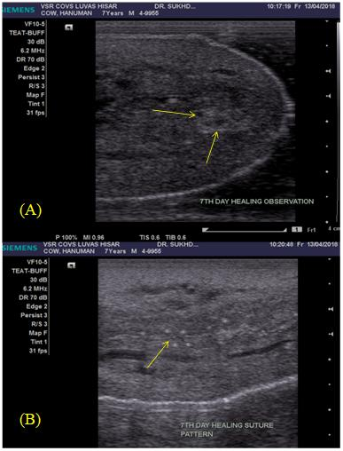

**Figure 5(A, B):** Ultrasonographic image of teat fistula on seventh day observation show hypoechoic pattern at healing area marked by arrow (water bath technique; vertical scan; 6.2 MHz linear probe)

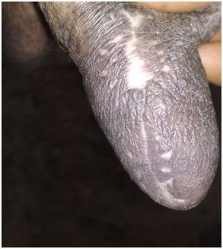

**Figure 6:** Gross image of completely healed of a teat fistula case on day 15th

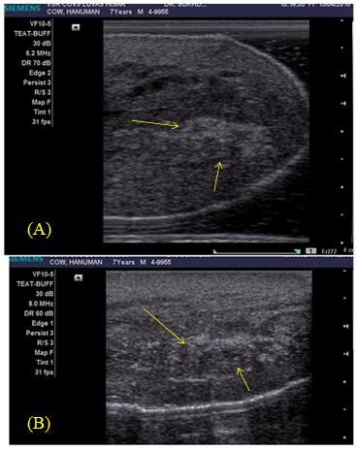

**Figure 7(A, B):** Ultrasonographic image of healed region of teat fistula on 15th day observation show more hyperechoic pattern at healed region marked by arrow. (Water bath technique; vertical scan; 8MHz linear probe)

**Group B:** The gross and ultrasonographically images of teat fistula **on** day 7 and 15th.

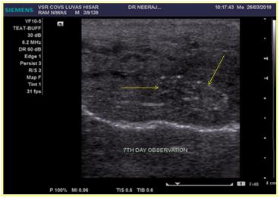

**Figure 8:** Ultrasonographic image on seventh day observation show hypoechoic and hyperechoic pattern at healing area marked by arrows (water bath technique; vertical scan; 6.2 MHz linear probe)

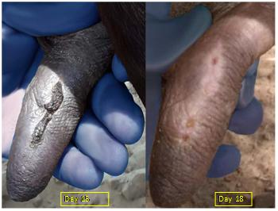

**Figure 9:** Gross image of healed teat fistula region on day 15th and 18th day

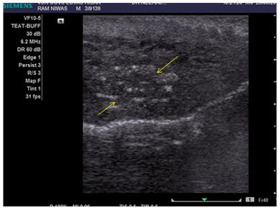

**Figure 10:** Ultrasonographic image of healed region on 15th day observation show more hyperechoic pattern at healed region marked by arrows. (Water bath technique; vertical scan; 6.2 MHz linear probe)

**Group C:** The gross and ultrasonographically images of teat fistula on day 7th follow:

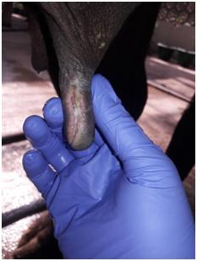

**Figure 11:** Gross image of unhealed teat fistula after 7th day of postoperative

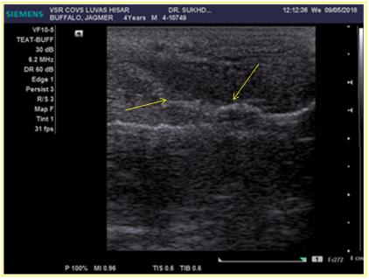

**Figure 12:** Ultrasonographic image of unhealed teat fistula tract marked by arrows after 7th day of postoperative (Water bath technique; vertical scan; 8 MHz linear probe)