ANNEXURE-5
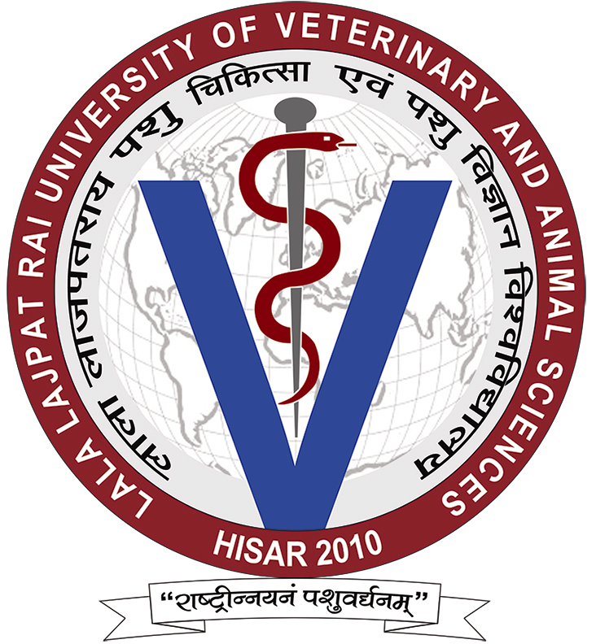REGISTERED/THROUGH MESSENGER

LALA LAJPAT RAI UNIVERSITY OF VETERINARY AND ANIMAL SCIENCES
HISAR-125004, HARYANA (INDIA)
Format for Notice Inviting Quotations.

1. Sealed quotations are hereby invited from the manufacturers/authorized dealers/suppliers/stationers for the items detailed below:

S. No. | Name & specifications of the Item | Quantity
(Note: Quantity may increase or decrease.)

2. Please mention specifically:
(i) Rate of Sales Tax/VAT to be charged, if any:
(ii) Payment:
(iii) FOR:
(iv) Validity period of the quotation:
(v) Delivery period:
(vi) Warranty/Guarantee:
(vii) Misc. charges such as Packing & Forwarding charges, Insurance charges, etc.:
(viii) Installation charges, if applicable:
3. Sample and specification is attached.
4. Sample wherever applicable may be sent alongwith the quotation so that the genuineness of the material could be judged.
5. Quotations will be received latest by _________________ up to ___________which shall be opened on ______________ at _____________ in the Office of the undersigned. The quotees or their authorized representatives are welcome to attend the meeting held for opening of quotations.
6. The University is situated outside the Municipal Limits, and as such, no Octroi is payable if the material is received by Rail. In case, the material is received through goods Transport Company by road, the transport companies charge delivery charges, labour charges and octroi charges. It may be mentioned specifically as to whether the material will be sent by rail or by road through goods Transport Company.
7. Charges not mentioned in the quotation shall not be paid by the University.
8. In case the quotation is approved, it will be required to submit 5% security of the total amount involved in the shape of FDR/DAC/Bank Guarantee in favour of Comptroller, LUVAS, Hisar. The security in other shapes viz. DD/Pay Order/Cheque will not be accepted. It is also mentioned here that the order will only be placed on the receipt of security within 7 days from the date of intimation for the award of contract/acceptance of quotation. The Store Purchase Officer/CPC can waive off the condition of deposition of 5% security if the firm is the genuine supplier of the goods in question/either on university rate contract.
9. Performance security in case of equipment/instrument (s) only: The responsive bidder shall be required to deposit Performance security in favour of Comptroller, LUVAS, Hisar. equivalent to five per cent (5%) of the cost of material ordered valid for guarantee/warrantee period plus 75 days. The security in other shapes viz. DD/Pay Order/Cheque will not be accepted. The Store Purchase Officer/CPC can waive off the condition of deposition of Performance Guarantees/other Securities keeping in view the quantity & nature of material.
10. Quotation received late or incomplete shall not be entertained, and shall be returned to the firm concerned without opening of the same. The University shall not be responsible for any postal/transit delay.
11. The University/its Offices at Hisar and Outstations do not make payment in advance or against documents supplied through Bank. However, as a matter of general policy, the University tries to make payment within 30 days of the delivery of the material subject to proper installation, wherever applicable and satisfaction of the Inspection Committee.
12. The family members of the University employee are not allowed to send quotations/tenders. Such quotations/tenders, if received, will outrightly be rejected.
13. The detailed instructions attached with the NIQ must be read carefully and meticulously complied with.

Store Purchase Officer

Encl: As above
CC: 1. Master file
2. Working Incharge, University Website for placing it on University website.

