ANNEXURE-8
Format for sending the Custom Duty Exemption Certificate to the Office of the Store Purchase Officer for countersignature of the Registrar, Lala Lajpat Rai University of Veterinary and Animal Sciences, Hisar

Subject: Purchase of Equipment (s): Custom Duty Exemption Certificate.

To meet the requirement of above item(s), a supply order was placed by __________________________ vide No. LUVAS/__________________ dated ___________ (Photocopy enclosed) with M/s______________________________________________________
for the following item(s):
Sr. No. | Name of item | Qty. | Cost

The items (s) to be purchased are covered under Govt. Notification No. 51/96- Customs dated 23.7.1996 for availing of Custom Duty exemption. The manufacturer has submitted Proforma Invoice No. _________________ dated ____________, which is in order (Original/Photocopy enclosed).
Two copies of Custom Duty Exemption Certificate duly signed by the undersigned with seal are placed below. These Certificates are returned after countersignature of the Registrar, Lala Lajpat Rai University of Veterinary and Animal Sciences, Hisar for the supply of the same to the supplier.
I undertake to furnish the details of the Custom Duty Exemption availed of while submitting Half Yearly Report for the period ending June/December by the specified date. An immediate action is requested.

Signature of the HOD
Encl: As above (Office Seal)

No. LUVAS/____________ Dated: ___________

Store Purchase Officer
ANNEXURE-9
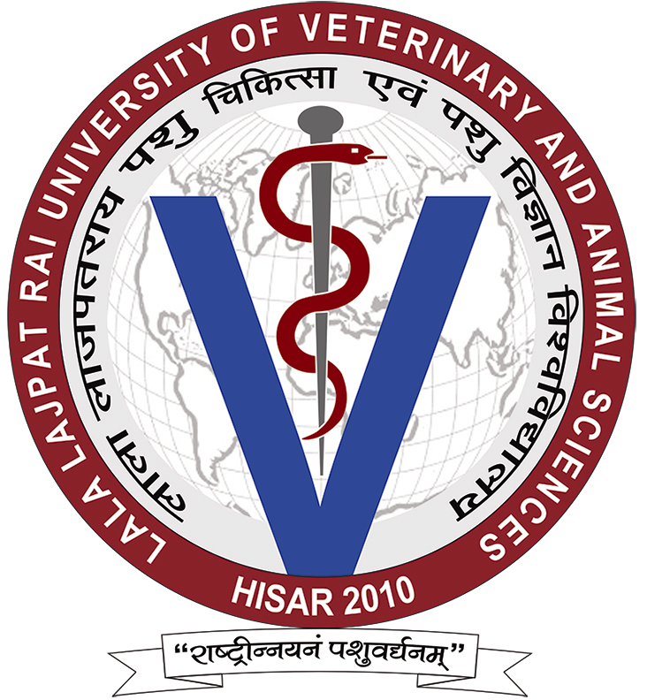 LALA LAJPAT RAI UNIVERSITY OF VETERINARY AND ANIMAL SCIENCES
HISAR-125004, HARYANA (INDIA)

Format for the Custom Duty Exemption Certificate
To
M/s. ___________________________________
___________________________________
___________________________________
Subject: Purchase of __________________________________ - Request for Issuing Custom Duty Exemption Certificate.

It is certified that Lala Lajpat Rai University of Veterinary and Animal Sciences, Hisar is:
- A University established by an Act No. 7 of the Legislature of the State of Haryana.
- An institution declared by Haryana State Legislative Assembly by law to be an institution of national importance.
- Registered with the Department of Scientific & Industrial Research, Ministry of Science and Technology, New Delhi for the purpose of availing Central Excise/Custom duty exemption in terms of Govt. Notification No. 51/96- Customs dated 23.7. 1996 as amended from time to time vide Registration No. TU/V/RG-CDE(1160)/2015 dated 27.01.2015 upto 31.08.2018.
- It is further certified that the item to be purchased viz., ____________________ ______________________________ (Name of Item) ___________________ (cost of Item) as per supply order No.____________________ dated ________ is required for research purpose only.

Signature of the HOD
(Office Seal)
Dated:

Countersigned

Registrar
Lala Lajpat Rai University of Veterinary and Animal Sciences
Hisar-125004 (Haryana)
(Office Seal)

