Clinical article
POST-PARTUM TOTAL UTERINE EVERSION IN A NON-DESCRIPT SOW
M. Periyannan, M. Selvaraju*, K. Senthilkumar, D. Gopikrishnan and V. Varudharajan
Department of Veterinary Gynaecology and Obstetrics,
Veterinary College and Research Institute, Namakkal – 637001
Tamil Nadu Veterinary and Animal Sciences University, India
Corresponding author: drmselvaraju1969@gmail.com
ABSTRACT
A rare case of postpartum total uterine eversion in a non- descript sow and its successful repositioning and management is reported.
Keywords: Eversion, Prolapse, Sow, Uterus
Protrusion or coming out of uterus and vagina through the vaginal opening is known as uterine prolapse (Bhattacharyya et al., 2012). It is commonly occurred few minutes to few hours after the fetal expulsion (Velladurai et al., 2016) and very rarely during 48 to 72 hours after the fetal deliver (Selvaraju et al., 2004 and Selvaraju et al., 2007) in farm animals. Prolapse of the uterus is occasionally seen in sows during or up to several days after parturition (Supakoran et al., 2017) and this report documents the successful management of total uterine prolapse in a non-descript sow.
Case history and Observation
A 3 years old pluriparous sow was brought to the VCC, VCRI Namakkal with the history of animal furrowed six piglets three days back normally. After three days, the animal showed continuous straining and the uterine horns prolapsed out. Clinical examination revealed that the sow was in lateral recumbency; dull and depressed with subnormal temperature. The prolapse of the uterine horns, cervix and vagina was noticed. The prolapsed mass was completely dry with lacerations on the base of the uterine horns (Fig. 1).
Corresponding author: drmselvaraju1969@gmail.com

Treatment and discussion
The sow was restrained with caudal epidural anesthesia using 2 ml of 2% lignocaine hcl. It was placed in the hindquarter elevator as in the figure 1. Prolapsed mass was washed with 2% potassium permanganate solution and lubricated with cetrimide cream (Fig. 2). Then, the vulval lips were held everted and the uterine horns were reduced through the cervix (Fig. 3) and repositioning was confirmed by passing the hand through the cervix. Postoperatively, the animal was treated with Inj. Ringers lactate 500 ml (i/v), Inj. Dextrose 20% 250ml (i/v), Inj. Calcium borogluconate 150 ml (i/v), Inj. Oxytocin 20 (IU), Inj. Ceftriaxone 1g (i/v), Inj. Flunixin meglumine 100 mg (i/m) and Inj. Chlorpheniramine maleate 30 mg (i/m) for 5 days and the animal recovered successfully.
Total uterine prolapse in sow was reported by Supakoran et al., (2017), Idia et al., (2019) and Nath et al., (2019). Occurrence of vaginal and rectal prolapse were more common in swine than the uterine prolapse (Supakoran et al., 2017) and partial or single horn eversion of uterus was common in bitch and sow (Parkinson and Noakes, 2019). Uterine prolapse is emergency obstetrical case and it needed early prompt attempt to save the animal (Selvaraju et al., 2007 and Velladurai et al., 2016). The prolapse of the uterine horns in the present case might be due to uterine inertia which might have caused the improper uterine involution and favoured the prolapse of the uterine horns. Thus, in the present case the total uterine prolapse in a sow was treated at the earliest and saved the life.
Summary
Successful reduction and repositioning of true uterine eversion in a sow was reported.

References
Bhattacharyya, H.K., Fazili, M.R. and Buchoo, B.A. (2012). Genital prolapse in crossbred cows: prevalence, clinical picture and management by a modified Bühner’s technique using infusion (drip) set tubing as suture material. Veterinarski arhiv. 82(1): 11-24.
Iida, R., Pineiro, C. and Koketsu, Y. (2019). Incidences and risk factors for prolapse removal in Spanish sow herds. Preventive Veterinary Medicine. 163(1): 79–86
Nath, A.K., Kumar, M. Bhattacharya, S. Chakraborty, D and De, D. (2019). Postpartum uterine prolapse in sow- a report of two cases. Haryana Vet. 58 (I): 131-132
Parkinson and Noakes (2019). Injuries and diseases consequent upon parturition In: Text book of Veterinary Reproduction and Obstetrics. (10th Edn.) Ed: Noakes, D.E Parkinson, T.J. and G.C.W. England,Elsevier, China, pp.189.
Selvaraju, M., Vijayanand, K.R., Parthiban, R., Vijay, D. and Richard Jagatheesan, P.N. (2004). Postpartum uterine prolapse in a doe. The Indian J. Ani. Reprod., 25(1):74-75.
Selvaraju, M., Ravikumar, K., Palanisamy, M., Prabaharan, V., Napolean, R.E., Ravi, R. and Chandrahasan, C. (2007). Total uterine prolapse after the abortion in a goat. Indian J. field vet 5(4): 73.
Supakorn, C., Stock, J.D., Hostetler, C. and Stalder, K.J. (2017). Prolapse incidence in swine breeding herds is a cause for concern. Open Journal of Veterinary Medicine. 7: 85-97.
Velladurai, C., Selvaraju, M. and Napolean, R.E. (2016). Postpartum total uterine prolapse and its management in a goat. Indian Vet. J., 93: 60-61.

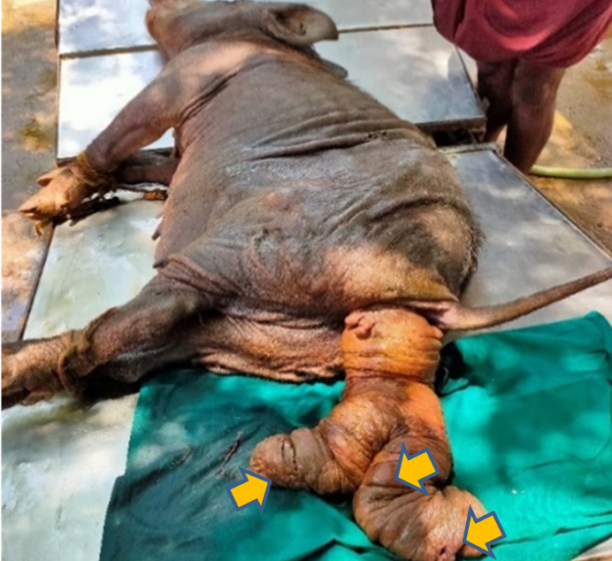
Fig. 1 Prolapse of the entire uterus with multiple lacerations in the uterine horn

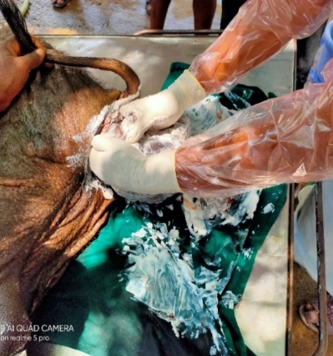
Fig. 2. Repositioning of the prolapsed uterus

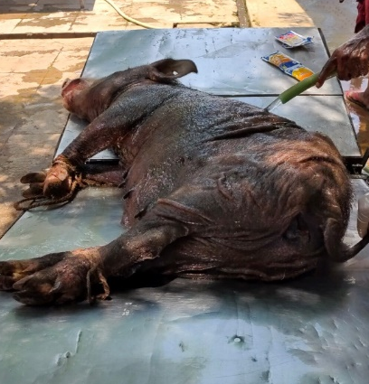
Fig. 3. Animal after the repositioning of uterus

