SURGICAL MANAGEMENT OF VAGINAL TUMOUR IN A CROSS BRED COW
SHARAD KUMAR, R B KUSHWAHA* and J S SOODAN
Division of Teaching Veterinary Clinical Complex
Faculty of Veterinary Sciences and Animal Husbandry
Sher-e-Kashmir University of Agricultural Sciences and Technology of Jammu
R S Pura-Jammu 181102, India
SUMMARY
An adult cow brought to the clinic with the history of protrusion of circular mass from the floor of vagina and dysuria. On physical examination of mass and its consistency, a vaginal tumour was diagnosed. The protruding mass was resected under sacro-coccygeal epidural analgesia using 7.0 ml of 2% lignocaine solution. The vulvar lips were looking normal immediately after surgical repair but complete healing of incision line occurred in couple of week.
Key Words: Cow, epidural analgesia, vaginal tumour
Vaginal tumours are uncommon in the cow but fibromas, fibrosarcomas, heiomyomas, hemagniomas, lymphosarcomas and carcinomas are reported vaginal tumours in the cow (Roberts, 1999; Yeruham et al., 1999). Vaginal tumours rarely cause infertility but may cause dystocia if they are very large in size. Most of the vaginal tumours are benign and pedunculated. In some cases they may protrude through vulva and required surgical removal (Musal et al., 2007; Hamali and Ashrafihelan, 2010). The present paper describes a case of large solid circumscribed tumour protruding from the vagina and its surgical removal under epidural analgesia in a cross bred cow.
An adult cross bred cow brought to the clinics with the history of protrusion of circumscribed mass from the vagina (Fig. 1). The cow exhibited dyschezia and dysuria clinical signs and had been inseminated 2 months ago and after that small but progressively growing mass was intermittently protruding and repositioned spontaneously. Distant examination was simulating cervico-vaginal prolapse but upon close and vaginal examination, the growth was revealed a solid circular shaped mass of small football sized protruding from the ventral commissure of vulva which was attached with left ventro lateral of cervical os. The case was tentatively diagnosed as vaginal tumour.
Epidural analgesia was induced by injecting 7 ml of 2% lignocaine hydrochloride at the sacro-coccygeal junction. Once the effect of epidural anaesthesia has come, the vaginal mass and canal was washed with antiseptic solution. Earlier authors have also reported removal of vaginal tumour in epidural analgesia with our without linear infiltration at the site of incision (Yeruham et al., 1999; Musal et al., 2007; Hamali and Ashrafihelan, 2010). A transverse linear incision was given at the mucosal surface of tumour and growth was removed by blunt separation off mucosal lining (Fig. 2). The growth was very large in size and hanging from vulva that resulted into stretching of pedunculated attachment. This could be the reason why authors preferred a vertical linear incision and then separated off tumour from mucosa by blunt dissection. During the excision procedure, an assistant grasped the pedunculated portion to prevent retracting back of mucosa deep into vagina immediately after removal. The extra portion of vaginal mucosa was resected and repaired in double layer with inversion pattern by catgut no. 1 (Fig. 3). Repair of vaginal mucosa is differ from case to case and as per tumour type. However, Musal et al. (2007) repaired incision first by interrupted cross mattress and then simple continuous pattern using cat gut no. 2. The resected mass was sectioned into two equal halves for gross morphology. The resected mass was appeared white dense fibrous homogenous structure. Although in this case histopathology was not done but from the sectioned macroscopic appearance (Fig. 4); it could have been a case of firbosarcomas tumour (Yeruham et al., 1999; Musal et al., 2007).
Post operatively, enrofloxacin (Quinintas®, Intas Pharmaceutical Ltd.) and meloxicam (Melonex®; Intas pharmaceutical Ltd.) each 15 ml were injected intramuscularly for 5 days. Owner was advised to wash the vaginal canal with KMnO4 solution. Initially there were discharge from the vagina but gradually it became normal in two weeks.
From the present paper, it was concluded that vaginal tumour could cause problem in insemination and thus such tumour may excise surgically under epidural analgesia. Though gross morphology of tumour may help in diagnosis but histopathology must be done to classify the type of tumour exactly.
REFERENCES
Musal, B., Ulutas, P. and Aydogen, A. (2007). Vaginal fibrosarcomas in a cow. Irish
Vet. J. 60(7): 424-425.
Hamali, H. and Ashrafihelan, J. (2010). Vaginal fibrosarcomas in a cow (A case report), International J. Vet. Res. 4(4): 225-228.
Roberts, S. J. (1999). Infertility in the cow. In: Veterinary Obstetrics and genital disease,
(Theriogenology). CBS Publishers and Distributors, India. P 493-494.
Yeruham, I., Perl, S., Orgad, U. and Yakobson, B. (1999). Tumours of the vulva and vagina in cattle – a 10-year survey. The Vet. J. 158: 237-239.

FIGURES

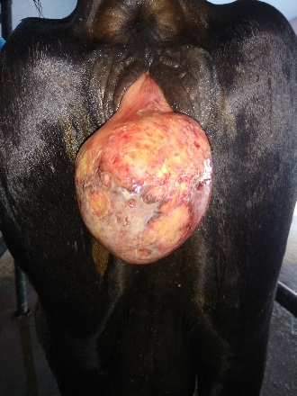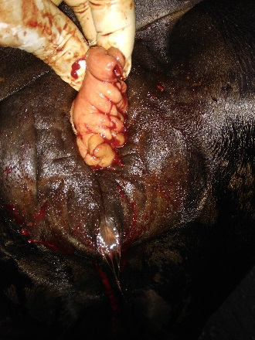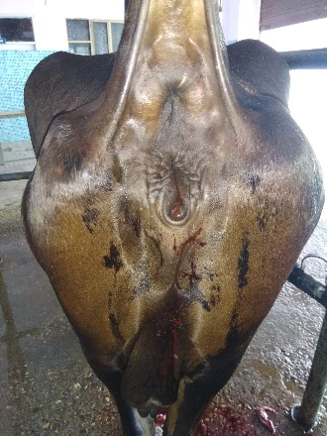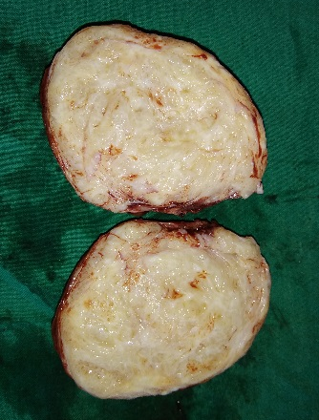
Fig. 1 Fig. 2 Fig. 3 Fig. 4

Fig. 1: A circumscribed mass hanging from the vagina and vulva
Fig. 2: After repair of vaginal mucosa in inversion pattern with chromic cat gut # 1
Fig. 3: After releasing of repaired vaginal mucosa.
Fig. 4: Gross morphology of cut surfaces of resected vaginal tumour.

*Corresponding author: kushwaharb@rediffmail.com

