Dystocia due to Schistosomus Reflexus (SR) in a murrah buffalo and its successful management
Alok Kumar,*¹ Atul Saxena, ² Ajeet Kumar Yadav³
1 Institute of Paraveterinary Sciences, (DUVASU), Mathura, U.P. INDIA
2 Professor and Head. Department of Veterinary Gynaecology and Obstetrics, College of Veterinary Science, DUVASU, Mathura, UP, INDIA.
3 B.V.Sc. & A.H. College of Veterinary Science, DUVASU, Mathura, UP, INDIA.

Summary
Present case report deals with a rare case of dystocia due to Schistosomus Reflexus (SR) in a murrah buffalo and its successful management via pervaginal delivery.
Keywords: Dystocia, congenital anomalies, schistosomus reflexus.
Schistosomus reflexus (SR) is a rare type of congenital syndrome of fetus and it is characterized by the presence of exposed abdominal and often thoracic viscera (schistosomus), and marked spinal angulation leading to a distinct ventral curvature of vertebral column. (reflexus). However the schistosomus aspect of the syndrome, i.e. the presence of a congenital schistocoelia, is reported in many species (Pivnick et al., 1998). Whereas the reflexus aspect is most often reported in ruminants (Bezek and Frazer, 1994). Occurrence of inherited congenital anomalies are common in all cattle breeds, moreover specific trait selection favours its spread in a population. (Whitlock, 2010). This condition pertains to the family of deformities involving failure of complete closure of ventral aspect of fetal body wall. However the exact cause leading to aforesaid defect can not be stated moreover Laughton et al.( 2005) indicated possibilities of genetic cause where fetus carries recessive gene from dam as well as sire leading to defective embryonic development. Azawi et al.( 2012) pointed out role of teratogens causing congenital defect because vulnerability of fetus at various stages of development remains in consistent, as every organ system of developing fetus carries a definite period of development, critical to it and can be influenced by exposure of teratogens. SR is very rare obstetrical condition ranging .01% to 1.3% of total bovine dystocia but mostly seen in cows as compare to other species. (Laughton et al., 2005)
An adult murrah buffalo at full term on her 4th parity brought to department of veterinary gynaecology and obstetrics, DUVASU Mathura, with history of continuous straining without delivery of fetus. Upon clinical examination, clinical parameters were observed within normal physiologic range. Vaginal examination revealed fully dilated cervix with all the four limbs and exposed abdominal cavity in the birth canal. The condition was diagnosed as dystocia due to schistosomus reflexus. Perianal region of the buffalo was thoroughly cleaned with 0.1% potassium permanganate solution and low plane epidural anesthesia was given with 2% Lignocaine hydrochloride followed by lubrication of birth passage with liquid paraffin, gentle traction was applied on the head and two limbs with simultanious repulsion on other limbs inside the uterus, the malformed fetus was delivered. The fetus was photographed and described macroscopically with following features. Scoliosis (reflexus) and unclosed thoracic and visceral wall with exposed viscera (Schistosomus) which confirmed our diagnosis as case of SR (Fig.1). Following delivery, the dam was treated with routine medication followed by uneventful recovery of the dam.
Figure 1. Photograph showing typical characteristic of schistosomus reflexus in a calf
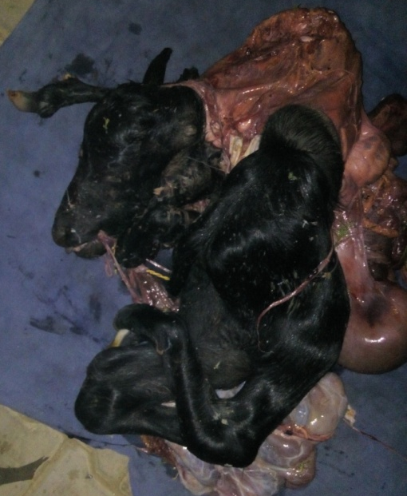
Dystocia can be defined as difficulty in parturition which may arise due to maternal factors and fetal factors. Fetal cause of dystocia is major contribution to total bovine dystocia (Kumar et al., 2018). In fact SR is rare but important fetal cause leading to considerable loss to cattle owner. The dystocia in this condition is due to fetopelvic disproportion and malposture. (Youngquist and Threlfall., 2007) The definite cause for the occurrence of SR has not been established yet but several authors suggested genetic and congenital cause responsible for SR. The present case confirms schistosomus reflexus defined by specific features i.e. ventral curvature as well as exposed viscera due to unclosed thoracic and abdominal wall which was evident in this case however ankylosis of the joints was not observed, and that may be a reason of its successful per vaginal delivery because in most cases acute spinal angulation and ankylosis of joints increases cross operational are, leaving it very difficult to manage per-vaginal delivery.
References
Whitlock, B.K. (2010). Heritable Birth Defects of Cattle. Applied Reproductive Strategies Conference Proceedings Nashville, TN. Pp.146-153.
Pivnick, E. K., Kaufman, R. A., Velagaleti, G. V. N., Gunther, W. M. and Abramovici, D. (1998). Infant with midline thoracoabdominal schisis and limb defects. Teratology. 58: 205–208.
Bezek, D. M. and Frazer, G.S.(1994). Schistosomus reflexus in large animals. Compend. Contin. Educ. Vet. Pract. 16: 1393 –1399.
Laughton, K.W., Fisher, K.R.S., Halina, W.G. and Partlow, G.D. (2005). Schistosomus Reflexus Syndrome: A Heritable Defect In Ruminants. Anat. Histol. Embryol. 34:312–318.
Azawi, O.I., Ahmed, O.S. and Abass, S.F. (2012). Iraq. J.Vet. Sci. 26:103-104.
Kumar, A., Saxena, A., Asre, R. and Mishra. K.K. (2018). A rare case of Hydramnios in cattle and its successful management. J. Entomol. Zool. Stud. 6(4): 1764-1766.
Youngquist, R.S. and Threlfall, W.R. (2007). Current Therapy in Large Animal Thereogenology, 2nd edition, Saunders-Philadelphia, U.S.A. Pp 313-468.

