DETECTION AND ISOLATION OF PESTE-DES-PETITS RUMINANTS VIRUS (PPRV) INFECTION IN SHEEP AND GOATS

SHALINI PANDEY ¹, GURPREET KAUR ^{2*}, D. MUTHUCHELVAN ³ AND P N DWIVEDI ⁴

Department of Veterinary Microbiology, COVS, Guru Angad Dev Veterinary and Animal Sciences University, Ludhiana-141001.

1.M.V.Sc Student:dr.shalini9651@gmail.com, Department of Veterinary Microbiology, COVS, Guru Angad Dev Veterinary and Animal Sciences University, Ludhiana-141001.

2 Assistant Professor: gurpreet7502@rediffmail.com, Department of Veterinary Microbiology, COVS, Guru Angad Dev Veterinary and Animal Sciences University, Ludhiana-141001.
3 Senior scientist: drchelva@gmail.com, Division of Virology, Indian Veterinary Research Institute, Mukteshwar-263138,Uttarakhand
4 Professor: dwivedi_micro@yahoo.co.in, Department of Veterinary Microbiology, COVS, Guru Angad Dev Veterinary and Animal Sciences University, Ludhiana-141001
*Corresponding author emai id: gurpreet7502@rediffmail.com

ABSTRACT

The present study was conducted for isolation and molecular detection of PPR virus in sheep and goat in Punjab region. Samples of ocular (25), nasal (25) and rectal swabs (25) separately from sheep and goats were collected thus making it to total of 150 samples. These samples were subjected to Reverse Transcriptase-Polymerase Chain Reaction (RT-PCR) for molecular detection of PPR virus. Out of 75 samples from 25 goats, three samples (4%) were found positive by F gene specific RT-PCR and all the samples from sheep were negative for PPR virus. From these samples, one PPRV isolate was isolated in Vero cell line.

Keywords: PPR, Sheep, Goat, RT-PCR, Virus isolation, Vero cell line
.

INTRODUCTION

Peste des petits ruminants (PPR) are known by numbers of name viz goat plague (Dhar et al 2002). Peste des petits ruminants (PPR) is an acute, viral and highly contagious disease of sheep and goats characterized by fever, catarrhal inflammation of ocular and nasal mucous membrane ,diarrhea, leucopenia, erosive stomatitis, gastroenteritis and pneumonia (Barrett et al 2005). The causative agent, PPR virus (PPRV) is an enveloped RNA virus belonging to the genus Morbillivirus of the family Paramyxoviridae (sub family Paramyxovirinae) under the order Mononegavirales (Gibbs et al 1979).The virus is pleomorphic (Haffar et al 1999) and the genome is a negative sense single stranded-RNA, approximately 16 Kilo bases (kb) long with negative polarity (Chard et al 2008). Based on sequence analysis of the F gene, phylogenetically, there are four different lineages (I–IV) of PPRV. Whereas lineage IV is believed to be prevalent in India, other lineages are prevalent in African countries (Sen et al 2010). PPR was first described in 1942 by Gargadennec and Lalanne in the Ivory Coast, West Africa (Gargadennec et al 1942.) PPRV was first isolated in sheep cell culture in 1962 (Gilbert and Monnier 1962) and it was first time observed under electron microscope in 1967 (Bourdin and Laurent-Vautier 1967). In India, its presence was first reported in 1987. The first confirmed outbreak of PPR in sheep with 25 % mortality was reported in Arasur village, Villipuram district of Tamil Nadu during 1987 (Shaila et al 1989). Thus to study the status of PPR in region under study; the present study was undertaken to isolate PPR virus from sheep and goats and also to detect the virus using molecular techniques.
MATERIAL AND METHODS
Sample collection
The samples were collected during the period between August 2017 to April 2018. A total of 150 samples viz.ocular(25), nasal (25) and rectal swabs (25) each from sheep as well as goat were collected in phosphate buffer saline (PBS); pH-7.4 from the various regions of Punjab, India. The samples were collected irrespective of the breed, age, sex, vaccination status and health status of the animal.
Processing of samples
The ocular, nasal and rectal swabs were collected individually in 4 ml of PBS. The samples were divided equally into two different microcentrifuge tubes (2 ml each). Then the samples were centrifuged at 3000 rpm for 2 minute and supernatant was collected. One part of the sample was kept at -20°C for RNA extraction. To another part of the sample, 10µl of antibiotic- antifungal solution (Sigma, USA) was added and it was incubated at 37°C for 30 min. and later stored at -80°C for virus isolation.
RNA isolation
RNA isolation from ocular, nasal and rectal swab samples was performed by using the commercially available kit according to the manufacture’s guidelines (Takara RNAiso Plus, Japan).The extracted RNA pellet was eluted in 25µl of nuclease-free water and stored at -80°C.The purify of the RNA was checked by measuring the optical density at 280-nm wavelength by Nanodrop (Thermo Fisher Scientific.USA).
First Strand cDNA Synthesis
The extracted RNA was converted into cDNA by using the commercially available kit (Takara-Prime ScriptTM First Strand Synthesis cDNA was done by 8µl of RNA template,1µl of random hexamers and 1µl of dNTPs (2.5mM).It was incubated at 65°C for 5min and then cooled immediately on ice. To this mixture a master mixture was added which was prepared by adding 4.0µl of Prime Script Buffer (5x), 0.5µl of RNA inhibitor (40 U/µl), 1.0µL of Prime Script RTase (200U/µL) and 4.5µL RNase-free water. The PCR tubes were placed in the thermocycler with the following thermal conditions, initially at 30°C for 10min, followed by at 42°C for 60 min and finally 95°C for 5 min for inactivation of the enzyme. The cDNA synthesized was stored at -20°C.
Amplification of F Gene of PPR Virus
PCR amplification was carried out by set of F-gene-specific primers (Table 1).

S.No | Gene | Primer name | Primer Sequence | Product size (bp) | Reference
1. | F-gene | ‘F’ | 5´GAGACTGAGTTTGTGACCTACAAGC-3´ | 372 | Forsyth and Barret  (1995)
 |  | ‘R’ | 5´ATCACAGTGTTAAAGCCTGTAGAGG-´3

The PPR vaccine was used as positive control and nuclease-free water was used as negative control. The master mix was prepared by adding 5.0µL of cDNA, 2.5µL of 10x PCR buffer (with MgCl₂), 1.0µL of dNTPs (2.5Mm each),0.5µL of Taq polymerase (5U/µL), 1.0µL each of forward (20 pmol/µL) and reverse primer (20 pmol/µL). The final volume was made 25µL with nuclease-free water. The reaction mixture was placed in thermocycler with following thermal cyclic conditions 1 cycle of 95°C for 5 min, 30 cycles of 94°C for 1 min, 50°C for 1min, 70°C for 7 min. PCR products (10µL) were visualized in 1.5% and run at 90V electrophorised gel for 30-35 min and visualized by gel documentation system.
Isolation of PPR Virus
Vero cell line available at PPR Laboratory of IVRI, Mukteshwar (India) was used for isolation of the virus
Virus isolation in vero cells
Vero (African green monkey kidney) cells were propagated in Eagle’s minimum essential medium (EMEM, Sigma, ST.Louis, MO, USA) containing 10% bovine calf serum (BCS) and antibiotics viz., Penicillin G and streptomycin 100 unit and 100µg per ml respectively. Incubated at 37°C with 5%CO₂ for 25-36hr, 25cc flask with 80-85% confluency were selected for virus infection. Then Discarded the EMEM and rinsed with fresh serum free EMEM 1ml of PCR positive PPRV inoculum were added to the flask for adsorption of virus. Incubated at 37°C for 1 hr with intermittent shaking of flask at 15min interval. After 1hr, fresh EMEM with 2-3% FBS was added and incubated at 37°C with 5% CO_{2.} Observe the flask daily for CPE and after 10th day of post-infection cells showed 80% CPE. CPE was observed after 3 passages. Cells were harvested and kept at 4°C for further use. The cell culture supernatant of sample showing CPE was subjected to RT-PCR for further confirmation.
RESULTS AND DISCUSSION
A total of 150 samples (ocular, nasal and rectal swabs) from sheep as well as goat were collected and subjected to Reverse Transcriptase-Polymerase Chain Reaction (RT-PCR) for molecular detection of PPR virus. Out of 75 samples from 25 goats, three samples (4%) were found positive by F gene specific RT-PCR showing an amplicon size of 372bp (Fig. 1) and all the samples from sheep were found negative for PPR virus. From the field samples, one PPRV isolate was isolated in Vero cell line. The presence of virus was further confirmed by RT-PCR.
Luka et al (2012b) conducted F-gene based molecular studies on PPR suspected oculo-nasal and blood samples. They found that 67 samples out of 383 were positives.
Chowdhury et al (2014) detected viral RNA by RT-PCR in 69 out of 84 nasal swab 59 out of 84 blood and 21 out of 21 lymph node samples in Bangladesh.
Kiran et al (2017) also conducted F-gene based molecular studies on PPR suspected oculo-nasal swab samples and found 28 positive samples out of 100 samples.
Ullah et al (2016) also observe isolation of PPR virus on Vero cells of faecal samples found positive in RT-PCR.
Kiran et al (2017) also subjected virus isolation of PPRV on B95a cell line and observed one sample showed the cytopathic effects (rounding of cells, syncytia formation and aggregation of cells) from four samples.
Fallahi (2017) studied on diagnosis of PPR virus from oral and nasal samples of sheep and goats and observed two isolates and were confirmed by using RT-PCR. Similar findings were reported by Bahadar et al (2009) in nasal and ocular samples

Fig.1. PCR for detection of PPR virus.

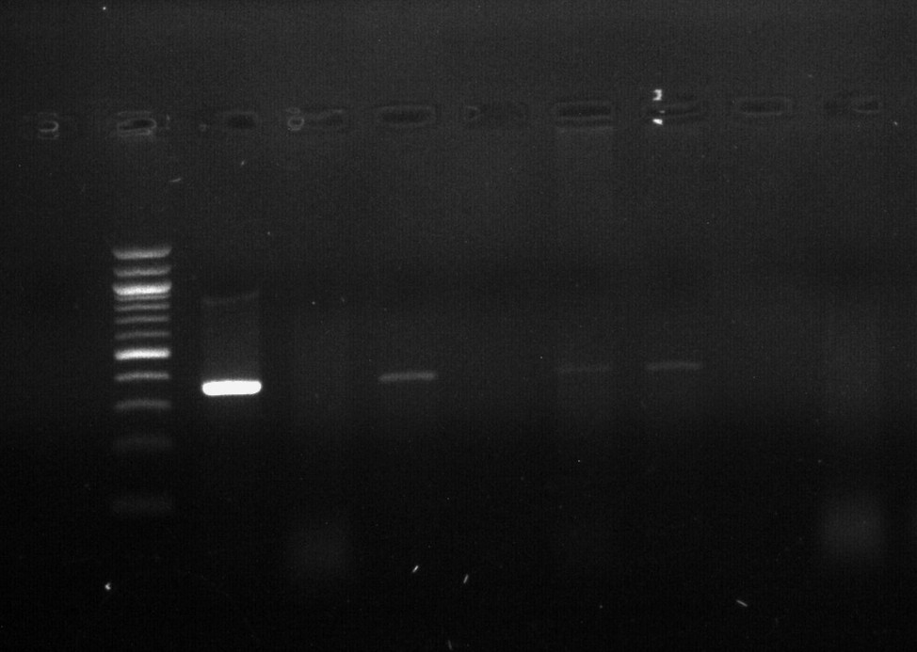
372bp
500bp
M 1 2 3 4 5 6 7 8 3 4 5
Lane M- Marker; Lane 1-Positive control; Lane 3,5,6 Positive samples; Lane 2, 4, 7 negative samples, Lane 8-Negative control

REFERENCES

Bahadar, S., Anjum, A. A., Ahmad, M. D., Hanif, A. (2009).Isolation and identification of peste des petits ruminants virus by cell culture and immunocapture enzyme linked immunosorbent assay. Journal of Animal & Plant Sciences. 19:19-121
Barrett, T., Banyard, A. C., Diallo, A. (2005). Molecular Biology of the Morbilliviruses Virus plagues of large and small ruminants. Elsevier, Amsterdam, the Netherlands, pp: 31–67.
Bourdin, P., & Vautier, A. L. (1967). Note sur la structure du virus de la peste des petits ruminants. Revue d’élevage et de médecine vétérinaire des pays tropicaux, 20(3): 383-386.
Chard, L. S., Bailey, D. S., Dash, P., Banyard, A. C. and Barrett, T. (2008). Full genome sequences of two virulent strains of Peste-des-petits ruminants virus, the Cote d’Ivoire 1989 and Nigeria 1976 strains. Virus Research 136: 192–197.
Chowdhury, E. H., Bhuiyan, A. R., Rahman, M. M., Siddique, M .S. A. and Islam, M .R.(2014). Natural Peste des petits ruminants virus infection in Black Bengal goats: virological, pathological and immunohistochemical investigation. BMC Veterinary Research 10: 263-72
Dhar, P., Sreenivasa B. P., Barrett T., Corteyn M., Singh, R. P. and Bandyopadhyay, S. K. (2002). Recent epidemiology of Peste des petits ruminants virus (PPRV). Veterinary Microbiology 88: 153–159
Fallahi, R. (2017). Isolation and molecular diagnosis of Peste des petits ruminants (PPR) virus from contaminated areas in Iran. Iranian Journal of Veterinary Science and Technology, 9(1): 17-21.
Gargadennec, L., Lalanne, A. (1942). La peste des petits ruminants (in French). Bull.des Serv. Zoo Techniques etdes Epizzoties de l’Afrique Occidentale Francaise 5:16–21.
Gibbs, E. P., Taylor, W. P., Lawman, M. J., Bryant, J. (1979). Classification of Peste des petits ruminants virus as the fourth member of the genus Morbillivirus. Intervirology 11(5): 268-274
Gilbert, Y and Monnier, J. (1962). Adaptation du virus de la peste des petits ruminants aux cultures cellulaires: notes préliminaires. Revue d’élevage et de médecine vétérinaire des pays tropicaux, 15(4):321-335..
Haffar, A., Libeau, G., Moussa, A., Cecile M., Diallo, A.(1999). The matrix protein gene sequence analysis reveals close relationship between PPR virus and dolphin morbillivirus. Virus Research 64: 69–75
Kaur, K., Kaur, G., Muthuchelvan, D and Dwivedi, P. N. (2018). Detection and isolation of Peste-des-petits ruminants (PPR) virusin goats of Punjab Region (India). Jornal of Immunology and Immunopathology. 20(1): 47-51.
Luka, P.D., Erume, J., Mwiine, F.N. and Ayebazibwe, C. (2012b). Molecular characterization of peste des petits ruminants virus from the Karamoja region of Uganda (2007–2008). Archives of Virology 157: 29–35.
Sen, A., Saravanan, P., Balamurugan, V., Rajak, K.K., Sudhakar, S. B., Bhanuprakash, V., Parida S., Singh, R. K. (2010). Vaccines against Peste des petits ruminants virus. Expert Review of Vaccines 9(7): 785–796.
Shaila, M. S., Purushothaman V., Bhavasar D., Venugopal K.,Venkatesan, R.A.(1989). Peste des petits ruminants in India. Veterinary Record 125: 602-06.
Ullah, R .W., Zahur, A. B., Ltif A., Dasti, J. I., Irshad H., Afzal M., Rasheed T., Malik, A. R and Qureshi, Z. A. (2016). Detection of Peste des petits ruminants viral RNA in fecal samples of goats after an outbreak in Punjab province of Pakistan: A Longitudinal Study. BioMed Research International 2016: 1-5

